BUILDING A MULTI-TASKING MODEL FOR TUMOUR
SEGMENTATION AND CLASSIFICATION USING AN
ADAPTIVE LOSS BALANCING ALGORITHM

BY

NWEZE, ISABELLA CHINASA (21CG029877)

A PROJECT SUBMITTED TO THE
DEPARTMENT OF COMPUTER AND INFORMATION
SCIENCES, COLLEGE OF SCIENCE AND TECHNOLOGY, COVENANT UNIVERSITY, OTA, OGUN STATE.

IN PARTIAL FULFILMENT OF THE REQUIREMENTS FOR
THE AWARD OF THE BACHELOR OF SCIENCE
(HONOURS) DEGREE IN COMPUTER SCIENCE.

JUNE, 2025

CERTIFICATION
I hereby certify that this project, was carried out by Isabella Chinasa NWEZE in the Department of Computer and Information Sciences, College of Science and Technology, Covenant University, Ogun State, Nigeria, under my supervision.

Prof. Olufunke O. Oladipupo _____________________
Supervisor Signature and Date

Prof. Aderonke A. Oni _____________________
Head of Department Signature and Date

DEDICATION
I dedicate this work to God, who has been my present help in times of need during my journey in this institution. I also dedicate this work to my loving friends and family, who support me.

ACKNOWLEDGEMENTS
My most profound gratitude goes to Almighty God, who has kept me and sustained me from the very start of my degree until now. I want to express my sincere gratitude to my elder sisters, Nikky and Ugo for all the encouragement and motivation they have given me throughout my four year journey here at Covenant University. Their constant advice regarding my academics was invaluable towards the completion of this degree. I am also extremely grateful to my parents, Chief Chukwuemeka Nweze and Mrs Ogechukwu Nweze for their endless sacrifice and contributions towards my education.
My gratitude also goes to my supervisor, Professor Olufunke Oladipupo, who despite her extremely busy schedule made out time for our weekly meetings and provided incredible insights throughout the course of this project. Finally I also appreciate the contributions of Mr Osofuye Damilola, Dr Azubuike Ezenwoke, Mr Chukwuebuka Ejiobih and Dr Alex, the Director of the Covenant University Medical Centre towards improving my project.

TABLE OF CONTENT
CONTENT PAGES
COVER PAGE i
CERTIFICATION ii
DEDICATION iii
ACKNOWLEDGEMENTS iv
TABLE OF CONTENT v
LIST OF FIGURES ix
LIST OF TABLES x
ABBREVIATIONS xi
ABSTRACT xii
CHAPTER ONE: INTRODUCTION 1
1.1 Background Information 1
1.2 Statement of the Problem 2
1.3 Aim and Objectives of the Study 3
1.4 Methodology 4
1.5 Significance of the Study 5
1.6 Scope of the Study 6
1.7 Project Outline 7
CHAPTER TWO: LITERATURE REVIEW 8
2.1 Preamble 8
2.2 Review of Multi-task Learning 8
2.3 Review of Loss Balancing 10
2.4 Review of Relevant Concepts 11
2.4.1 Artificial Intelligence 11
2.4.2 Machine Learning 12
2.4.3 Deep Learning 14
2.4.4 Convolutional Neural Networks (CNN’s) 15
2.4.5 Semantic Segmentation with Swinunet 16
2.4.6 Classification with EfficientNet 16
2.5 Review of Related Works 17
2.5.1 Dynamic Restrained Weighting Loss for Multi-task Learning of Vocal Expression 17
2.5.2 AHU-MultiNet: Adaptive Loss balancing Based on Homoscedastic Uncertainty in Multi-task Medical Image Segmentation Networks 18
2.5.3 GradNorm: Gradient Normalization for Loss Balancing in Deep Multi-task Networks 19
2.5.4 BT-Net:An End-to-End Multi-task Architecture for Brain Tumour Classification,Segmentation, and Localization from MRI Images. 19
2.5.5 Dual-Balancing for Multi-task Learning 19
2.5.6 PS-MTL-LUCAS: A partially shared multi-task learning model for simultaneously predicting multiple soil properties 20
2.5.7 Multi-Adaptive Optimization for multi-task learning with deep neural networks 21
2.6 Review of Existing Systems 21
2.6.1 Unified Pipeline for Simultaneous Brain Tumour Classification and Segmentation using Fine-Tuned CNN and Residual UNet Architecture 21
2.6.2 Review of the NeuroImaging Sequence Examiner (NISE) application 25
2.7 Gaps Identified in Literature 27
2.8 Summary of Literature Review 29
CHAPTER THREE: SYSTEM ANALYSIS AND DESIGN 30
3.1 Preamble 30
3.2 Requirement Analysis 31
3.2.1 Functional Requirements 31
3.2.2 Non-Functional Requirements 31
3.3 Model Development 31
3.3.1 Data Collection and Pre-processing 31
3.3.2 Data Sources 32
3.3.3 Metadata Compilation 32
3.3.4 Dataset Splitting 33
3.3.5 Pre-processing and Augmentation Pipeline 33
3.4 Multi-task Model Architecture 34
3.4.1 EfficientNet (Classification Branch) 35
3.4.2 UNet (Segmentation Branch) 36
3.5 Adaptive Loss Balancing Function 37
3.5.1 Objective of the Adaptive Loss 37
3.5.2 Structure Of The Combined Loss Function 37
3.5.3 Implementation Details 38
3.5.4 Regularization Strategy 38
3.5.5 Outcome and Effectiveness 38
3.6 Model Training and Evaluation 38
3.6.1 Training Configuration 38
3.6.2 Training Process 39
3.6.3 Validation and Monitoring 40
3.6.4 Evaluation Metrics 40
3.7 Web Application Development 40
3.7.1 Flask Backend 41
3.8 Frontend with React 42
3.8.1 UML Modelling 43
3.9 Website Evaluation 46
CHAPTER FOUR: SYSTEM IMPLEMENTATION 47
4.1 Preamble 47
4.2 System Requirements 47
4.2.1 Hardware Requirements 47
4.2.2 Software Requirements 47
4.3 Implementation Tools 48
4.3.1 Python 48
4.3.2 React 48
4.3.3 Visual Studio Code 49
4.3.4 Github 49
4.3.3 Tailwind CSS 49
4.4 Development Methodology 49
4.5 Evaluation of the System 50
4.5.1 Evaluation Criteria 51
4.5.2 Evaluation Results 52
4.5.3 Graph Visualization 52
4.5.4 Benchmarking Against Existing Papers 54
4.5.5 User Feedback and Usability Evaluation 56
4.5.6 Discussion 56
4.6 Program Modules and Interfaces 57
4.6.1 Authentication Page 57
4.6.2 Upload Page 58
CHAPTER FIVE: SUMMARY, RECOMMENDATIONS AND CONCLUSIONS 60
5.1 Summary 60
5.2 Recommendations 61
5.3 Limitations of the Study 61
5.3 Conclusion 61
REFERENCES 63

LIST OF FIGURES
FIGURES TITLE OF FIGURES PAGES
2.1 Classification model architecture 22
2.2 RUNet Architecture for segmentation 23
2.3 Proposed framework for the unified pipeline system 25
2.4 Interface and output of the NISE app 27
3.1 Project workflow 30
3.2 Multi-task Model Architecture 35
3.3 Testing Image 40
3.4 Use Case Diagram 44
3.5 Activity Diagram 45
4.1 Accuracy Graph Visualization 53
4.2 Training Loss Graph Visualization 54
4.3 Authentication Page 58
4.4 Upload Page 59
4.5 Results on Upload Page 59

LIST OF TABLES
TABLES TITLE OF TABLES PAGES
1.1 Objectives-Methodology Mapping table 4
4.1 Hardware Requirements Table 47
4.2 Software Requirements Table 48
4.3 Benchmarking Table 55

ABBREVIATIONS
AI | Artificial Intelligence
CNN | Convolutional Neural Networks
CSS | Cascading Style Sheets
CSV | Comma Separated Values
CT | Computed Topography
DICOM | Digital Imaging and Communications in Media
DL | Deep Learning
DWA | Dynamic Weight Average
GPU | Graphics Processing Unit
IoU | Intersection over Union
JPEG | Joint Photographics Expert Group
MRI | Magnetic Resonance Image
MTL | Multi-task Learning
NISE | NeuroImaging Sequence Examiner
NIVE | NeuroImaging Volumetric Extractor
PNG | Portable Network Graphics
RAM | Random Access Memory
RNN | Recurrent Neural Network
SVM | Support Vector Machine
UW | Uncertainty Weighting

ABSTRACT
Medical imaging plays an important role in the early detection and treatment of brain tumours. However due to reduced availability of neurosurgeons in Nigeria , manually segmenting tumour regions and classifying tumour types can be time consuming and prone to inconsistencies. This project addresses these challenges by developing a multi-task learning model that performs both tumour segmentation and classification using Magnetic Resonance Imaging (MRI) data. The multi-task model uses an adaptive loss balancing algorithm to optimize both tasks simultaneously without compromising accuracy. EfficientNet-B0 is employed for tumour classification, while a U-Net architecture is used for segmentation. The BraTS MRI 2020 dataset and the Figshare Brain MRI Dataset are used for training and evaluation. This project followed a comprehensive approach including data extraction, pre- processing, model design, training and evaluation. Results show that the adaptive loss mechanism improves task coordination, with the model achieving strong performance in both segmentation (based on Dice scores) and classification (based on accuracy and F1-score), validating the effectiveness of the multi-task setup.

Keywords: Medical Imaging, Multi-task Learning, Segmentation, Classification, Loss Balancing, MRI Image

CHAPTER ONE
INTRODUCTION

1.1 Background Information
With the rise of machine learning, various methods have emerged for training neural networks such as transfer learning, supervised learning, reinforcement learning and multi-task learning (Ryu et al., 2023). While multi-task learning has unique advantages it is not as popular as other training methods and is much less frequently utilized, as many practitioners prefer to train separate neural networks for distinct task (Ryu et al., 2023). Multi-task learning focuses on training a single neural network to perform multiple, related tasks simultaneously, which offers significant benefits in terms of computational power and resource efficiency (Lee & Son, 2022). By sharing representations between tasks, multi-task learning can lead to better generalization and improved performance with lower computational costs (Li et al., 2023).
Even though multi-task learning (MTL) offers several advantages like reduced training time and better data efficiency, it also presents several challenges that can hinder its effectiveness. One challenge highlighted is the varying learning rates required by different tasks (Standley et al., 2019). Another important problem is the balancing of loss functions from individual tasks during training (Du et al., 2024). If these issues are not properly managed, one task may dominate the others during the training process and lead to a sub-par performance across all tasks (Standley et al., 2019). Providing proper attention to every task is the key to reach the best performance, and attempting to reconcile these tasks is still a major issue in the multi-task learning settings.
The tumour segmentation and classification multi-task model integrated an adaptive loss balancing algorithm to deal with the mentioned issues. This algorithm was able to dynamically balance the losses associated with each task. The algorithm did this by assigning weights to the two tasks based on the perceived degree of difficulty and dynamically adjusting the weights during the training process. This approach builds on promising results from related domains, where dynamic adjustments have shown potential to improve training efficiency and task performance (Song et al., 2022).
Existing literature shows that the conventional loss balancing approaches have been static in many cases and they do not respond to the dynamism of multi-task training (Lin et al., 2023). The conventional approaches have concentrated on the manipulation of forward pass of the network or optimization of the architecture without targeting the ultimate problem of gradient imbalances throughout the backpropagation (Chen et al., 2017). Such imbalances may adversely affect training by causing training tasks to cause gradients with large, unbalanced magnitudes. The adaptive loss balancing algorithm used in this project bridges this gap by adapting the weights on tasks to ensure that the learning is balanced to offer a more comprehensive solution to the problem specific to multi-task learning.
The adaptive loss balancing strategy guaranteed a more balanced learning between the two tasks, and this strategy resulted in a better accuracy in the two tasks. The significance of this research lies not only in its potential to advance the field of multi-task learning but also in its applicability to various domains where similar challenges exist, thereby contributing to more effective machine learning solutions in healthcare and other fields .

1.2 Statement of the Problem
The multi-task learning approach offers high potential for resource-efficient neural networks by enabling them to perform multiple related tasks within a single model (Zhai et al., 2024). This efficiency is especially critical in resource-constrained sectors like neurosurgery, where there is often a shortage of skilled professionals and tools to analyse large volumes of complex medical data (Morgan & Nwatuzor, 2020). However, this method faces a critical challenge which is balancing task performance effectively during training.
Previously, conventional multi-task models often relied on fixed-weight loss functions, assigning equal weights to all tasks or relying on static assumptions about their relative importance (Chen et al., 2017). Although this static approach is simple, it did not suffice when it comes to dealing with the relative complexities and changing needs of tasks in training. Consequently, some of the work would tend to finish quicker than others, resulting in poor overall performance and an unbalanced model (Liu et al., 2022).
In recent years, however, dynamic loss-balancing algorithms have emerged as a solution to this problem. To overcome the shortcomings of the static methods, dynamic methods like dynamic weight adjustments, uncertainty weighting, and gradient-based methods like gradient normalization have been designed (Gong et al., 2019). These algorithms adaptively adjust loss weights during training, ensuring that each task receives the attention it requires based on real-time conditions. Dynamic balancing approaches offer great improvement in performance and stability of multi-task learning systems by considering the factors such as task difficulty, training dynamics, and conflicting gradients.
This study built an enhanced multi-task model specifically designed for MRI brain tumour segmentation and classification. The nature of tasks being trained in a multi-task environment is crucial in determining the most appropriate loss-balancing strategy (Standley et al., 2019). For instance, tasks with conflicting gradients may benefit from gradient-based methods like GradNorm, which normalize gradients across tasks to ensure consistent optimization (Chen et al., 2017). Meanwhile, tasks with uncertain difficulty are better suited to uncertainty weighting, which adjusts loss weights based on task confidence (Liu et al., 2022). Additionally, tasks that evolve dynamically during training, as is common with medical imaging data, may require strategies like dynamic weighting to adapt to these shifts (Li et al., 2023). By tailoring the algorithm to the specific characteristics of the segmentation and classification tasks, this study optimizes multi-task performance and provide insights for broader applications in medical and other domains.

1.3 Aim and Objectives of the Study
The aim of this study is to build a multi-task model for tumour segmentation and classification using adaptive loss balancing. The objectives are listed below:
- To gather and pre-process a comprehensive dataset of MRI brain scans for training and evaluating the model.
- To develop a multi-task model for brain tumour segmentation and classification.
- To evaluate the performance of the multi-task model by benchmarking it against existing approaches for tumour segmentation and classification.
- To integrate the multi-task model into a web application for real-time segmentation and classification of MRI brain scans.
- To evaluate the usability of the web application.

1.4 Methodology
This project followed the standard step by step procedures involved in carrying out a machine learning project, from data collection and pre-processing, to feature engineering, model training and then integration into a web application. Table 1.1 shows the one to one mapping of the objectives to the methodology.
Table 1.1: Objectives-Methodology Mapping Table
S/N | OBJECTIVES | METHODOLOGY
1. | To gather and pre-process a comprehensive dataset of MRI brain scans for training and evaluating the model. | - A publicly available MRI brain scan dataset, called BraTS was downloaded from Kaggle. A brain tumour dataset containing 4 folders namely: no-tumour, glioma tumour, meningioma tumour and pituitary tumour was also downloaded from Figshare.  - The images were pre-processed by resizing to a standard size of 256x256. The pixel values were normalized and converted to the required format for training the model.  - The dataset was augmented by flipping, rotating and adjusting the intensity in order to increase diversity and prevent overfitting.  - The dataset was split into training, validation and test sets of 70%, 15% and 15% respectively.
2. | To develop a multi-task model for brain tumour segmentation and classification with an adaptive loss balancing algorithm. | - A shared encoder-decoder architecture was implemented using SwinUNet for segmentation and EfficientNet for classification.  - Task specific loss functions such as Dice loss for segmentation and Categorical cross-entropy loss for classification, were defined.  - The adaptive loss balancing algorithm that uses uncertainty based dynamic weighting to adjust task priorities in the model was implemented.  - The model was trained using the already pre-processed dataset, with backpropagation and Adam optimizer for parameter updates.  - The model was validated using cross fold validation and data augmentation to prevent overfitting.
3. | To evaluate the performance of the multi-task model by benchmarking it against existing approaches for tumour  segmentation and classification. | - Performance metrics including : dice score and IoU (Intersection over Union) for segmentation, accuracy and f1 score for classification were used for assessment.  - The model was benchmarked against existing multi-task models for brain tumour segmentation and classification with standard datasets.
4. | To integrate the multi-task model into a web application for real-time segmentation and classification of MRI brain scans. | - The trained multi-task model was integrated into a web application with a Flask backend for real-time inference.  - React and Tailwind were used to develop the frontend of the website.
5. | To evaluate the usability of the web application. | - Post-Study System Usability Questionnaire standard questionnaires were issued to respondents in a clinical setting to analyse website usability and get user feedback.

1.5 Significance of the Study
This project contributes a great significance to the field of multi-task learning. The significance of the study is listed below:
- The findings from this study will have great impact on resource optimization in machine learning, instead of using different hardware to train different tasks, multiple tasks can be combined efficiently in a single neural network.
- This project will provide the necessary foundation to explore building a comprehensive unified architecture for the segmentation and classification of MRI brain scans.
- This project holds great significance to the resource constrained healthcare sector in Nigeria. It provides a system that can aid tumour diagnosis and make treatment faster and more efficient.

1.6 Scope of the Study
This study focused on building a multi-task deep learning model for brain tumour segmentation and classification, with an emphasis on designing an adaptive loss balancing algorithm to optimize the model's performance. The primary goal was to construct a shared encoder-decoder architecture, where a shared encoder extracts features from MRI scans, followed by two task-specific heads: one for segmentation using a SwinUNet based architecture and another for classification using EfficientNet. The adaptive loss balancing algorithm was integrated into the multi-task learning process to dynamically adjust task specific weights based on performance metrics, such as loss magnitudes, uncertainty scores, and convergence rates. This ensured that both the segmentation and classification task received optimal contributions during training, preventing one from dominating the other and this lead to an overall improved model performance.
This study evaluated the multi-task model by benchmarking it against existing multi-task models that perform both brain tumour segmentation and classification using the standard datasets. Standard performance metrics such as accuracy and IoU for segmentation, and accuracy and F1-score for classification were used for comparison.
Furthermore, the multi-task model was integrated into a web application, which allowed for real-time analysis of MRI scans for both segmentation and classification tasks. The web application was developed using a Flask backend and React for the frontend interface, facilitating an interactive and user-friendly platform for medical professionals. Usability testing was conducted in a clinical setting to assess the system's usefulness and interface quality, ensuring that the web application provides a practical tool for real-world medical imaging and diagnosis.

1.7 Project Outline
Chapter One of this project chapter covers the background of the study, the problem statement, the study’s aim and objectives, its significance, limitations and its scope . Chapter Two did a literature review that covers the concepts related to the topic, the existing methods, and existing systems that implement the methods used to solve the problem. Chapter Three describes the analysis and design of the system. Chapter Four shows a detailed implementation of the system and the results obtained. Chapter Five summarises the project and gives recommendations, suggestions, conclusions and references.

CHAPTER TWO
LITERATURE REVIEW

2.1 Preamble
This chapter provides a literature review of the core concepts, the general problem space, and the specific domain under review. It proceeds to explore key concepts that are important in the development of a multi-task model using adaptive loss balancing as well as the relevant architectures for implementing segmentation and classification of MRI brain scans. The review also explores a list of existing solutions and systems that have been used to solve similar problems in the problem space, establishing a platform for the project's approach.

2.2 Review of Multi-task Learning
Multi-task learning (MTL) is a machine learning sub-field that improves learning efficiency and prediction accuracy by training models on multiple related tasks simultaneously using a shared representation (Lee & Son, 2022). Inspired by human learning, where skills from one task can aid another. MTL seeks to leverage the knowledge gained in one task to enhance the generalization performance of others (Li et al., 2023). By enabling tasks to share domain-specific insights, MTL reduces the need for large, task-specific datasets while enhancing overall model performance.
According to Richard Caruana, multi-task learning was introduced long before the introduction of deep learning , but the strong learned features within deep networks and their excellent single-task performance have kindled renewed interest (Chen et al., 2017). Although the primary focus of this study is medical imaging, multi-task learning has applications in many other fields, from natural language processing and speech synthesis, to very domain-specific applications such as traffic prediction (Lin et al., 2023).
MTL is often compared to related paradigms such as transfer learning, multi-label learning, and multi-output regression. While transfer learning focuses on improving a specific target task using knowledge from source tasks, MTL treats all tasks equally, aiming to optimize performance for all simultaneously (Standley et al., 2019). In contrast to transfer learning’s task prioritization, MTL’s uniform focus ensures that knowledge is bidirectional and not confined to a single target task (Obonyo & Ruiru, 2019).
MTL's power lies in its use of inductive transfer learning, where representations are shared across tasks to improve performance, particularly in data-scarce or goal-correlated settings (Nisar et al., 2023). In medical imaging, for example, MTL models can be used to classify MRI scans for the presence of tumours and simultaneously segment tumour regions, transferring knowledge between tasks to improve overall accuracy (Rabby et al., 2024). Such multi-tasking not only reduces computational overhead but also makes applications with limited data and resources simpler.
However, practitioners must carefully consider two things prior to the use of MTL: what to share and how to share (Standley et al., 2019). It is important to determine which tasks can be trained together, since tasks must be complementary and not opposing in order to benefit from shared learning (Nisar et al., 2023). In addition, it is essential to decide what knowledge to transfer during training, i.e., features, parameters, or representations, to enable efficient transfer and minimize interference between tasks (Gong et al., 2019).
Despite its advantages, MTL is faced with challenges like overfitting and task balancing (Hervella et al., 2024). In some cases, a task can dominate the learning process, resulting in poorer performance for the remaining tasks (Standley et al., 2019). This is especially difficult in scenarios with opposing gradients, where the optimization of one task has a detrimental effect on another (Nisar et al., 2023). MTL models also usually require complex architectures and hyperparameter searching, making them computationally expensive and harder to use for real-world applications (Zhang & Yang, 2017).
Recent advances, such as adaptive loss balancing algorithms, address these limitations by updating task weights iteratively to encourage balanced learning (Song et al., 2022). These improvements ensure that all tasks benefit equally from the learning process, enhancing the use of MTL across applications (Hervella et al., 2024). As research continues, the potential of MTL only increases, and it is now a cornerstone of modern machine learning methodologies.

2.3 Review of Loss Balancing
Loss balancing, in the context of multi-task learning (MTL), refers to the process of managing the relative importance of tasks by adjusting each task's loss function (Zhang & Yang, 2017). The primary goal is to prevent some tasks from dominating the learning process at the expense of the performance of other tasks. This is particularly important when the tasks differ in their levels of difficulty or when the data distributions between tasks are not balanced (Nisar et al., 2023). Balancing the losses ensures that each task has its own equitable contribution to the overall learning, which leads to generalization and task performance improvement.
The requirement for loss balancing in MTL is because the range of loss can be different for different tasks, and hence some tasks can overwhelm the others while training. For instance, in an MTL model where both tasks are to classify MRI images and also segment the same images, the segmentation task will naturally have a higher loss due to its finer granularity. When both tasks are being trained using a fixed, imbalanced loss function, the model may end up paying more attention to the task with the higher loss at the expense of the other task. Therefore, dynamic loss balancing is required to ensure that all tasks are optimally trained and not one of them dominates the others (Nisar et al., 2023).
Historically, loss balancing in MTL originated with the discovery of MTL itself (Jaradat et al., 2024). Static methods of loss balancing depended on pre-defined weights for each task according to domain knowledge or empirical study (Gong et al., 2019). Nevertheless, this method was not optimal because it was not flexible in changing the loss balance during training. One of the very first loss balancing efforts was done through the early work of Rich Caruana in the 1990s, when he introduced the idea of multi-task learning (Chen et al., 2017). Although early methods simply utilized uniform weights to ensemble the losses from multiple tasks, as research evolved, scientists sensed the need for more sophisticated, adaptive strategies (Gong et al., 2019).
The evolution from static to dynamic loss balancing began in earnest with the introduction of uncertainty weighting (UW) by Gong et al. (2019). Uncertainty weighting was one of the first methods to adaptively adjust the importance of each task during training based on the uncertainty of the task. The idea behind uncertainty weighting is that tasks with higher uncertainty should be given more weight as they require more attention during training (Song et al., 2022). This approach was a step in the direction of more adaptive, data-dependent methods for loss balancing, where the task weights could be changed in real time based on the learning process.
A paper by Gong et al. (2019) categorizes loss functions into two broad categories: Pure loss functions and gradient based functions. Pure loss techniques include Uncertainty weighting (Cipolla et al., 2018) and Dynamic weighting average (DWA) while gradient-based loss includes Gradient Normalisation (Chen et al., 2017), Multiple gradient descent algorithm (McCaughan et al., 2023), Projecting Conflicting Gradient, Gradient Sign Dropout, Impartial Multi task learning (Yuan & Zhang, 2023) and Gradient Vaccine. This research intends to focus on pure loss functions since the two tasks being trained together, segmentation and classification, are related and do not have very opposing gradients. Also, the pure loss methods discussed above are simpler to apply and enjoy common usage and acceptance (Song et al., 2022).As the research area advances, more sophistication in balancing losses is anticipated, enabling MTL models to attain even better performance on varied tasks.

2.4 Review of Relevant Concepts
This section details the various concepts that are relevant to this project. They include:

2.4.1 Artificial Intelligence
Artificial intelligence (AI) applies computational algorithms to analyse and comprehend complex datasets. AI is transforming medical diagnostics in imaging operations (for segmentation: specifying constituents, whole or partial, and diagnosing, and classification: identifying similarity, similarity, and potential for disaster), though its primary objective is to mimic cognitive operations like learning, reasoning, and self-refreshing (Tian et al., 2023). AI uses patterns from enormous databases of tagged images beyond medicine, and its phenomenal speed, efficiency, and accuracy in generating probability predictions over a wide spectrum (any prediction model will have variables) has profound implications for future diagnostic accuracy and treatment.

In the specific field of MRI brain scan diagnostic image analysis, AI algorithms can classify brain tumours, identify brain injury, and predict possible future status for certain neurological diseases (Kaur et al., 2020). For example, they can tell whether a tumour is benign or malignant by noticing subtle differences in an MRI image. Segmentation of various brain structures can be done using AI on the brain as a whole, and in segments, which may be beneficial for everyone for the measurement of total brain volume, abnormalities, and then preparation for a surgical procedure (Kaur et al., 2020). If AI can perform these steps for the radiologist, it can save the radiologist a lot of time and let them focus on harder cases.
The use of AI in MRI brain scan analysis offers several benefits. Firstly, it can improve the accuracy and speed of diagnosis, leading to earlier interventions and better patient outcomes (Kaur et al., 2020). Secondly, AI can help to standardize diagnostic criteria, reducing inter-observer variability and ensuring more consistent results across different healthcare settings. Thirdly, AI can uncover hidden patterns in MRI data that may not be readily apparent to human observers, potentially leading to new insights into the diagnosis and treatment of neurological disorders.
While AI has great potential in medical imaging, it comes with several challenges. One of them is the transparency of how some AI algorithms arrive at their conclusions, which is sometimes called the "black box" problem. This openness can deter clinicians to have faith and utilize these systems. The second issue is making sure that AI models are trained on a wide range of datasets so that they are unbiased and provide the same results to patients from various groups. Legal and ethical considerations, including patient privacy and confidentiality, as well as liability for incorrect diagnoses, also must be met with serious deliberation (Kaur et al., 2020).

2.4.2 Machine Learning
Machine learning (ML) is a branch of artificial intelligence (AI) that centres on creating algorithms and statistical models that enable computers to learn and improve from data without explicit programming. These systems analyse input data to make predictions or decisions, with their accuracy improving as they are exposed to more information. The learning process involves training algorithms on extensive datasets, fine-tuning their parameters to enhance performance in specific tasks. ML tasks are categorized as supervised (using labelled datasets), unsupervised (identifying patterns in unlabelled data), or semi-supervised (a mix of labelled and unlabelled data) (Zhai et al., 2024).
Machine learning (ML) is crucial in medical imaging, leveraging technologies such as Xrays, MRI, cardiac MRI , Computed Topography (CT) scans, mammograms, and histopathological images to aid in diagnosing and treating diseases. In the context of MRI brain scans, ML algorithms excel at tasks like classification and segmentation, enabling the identification of brain tumours, damaged regions, and disease progression. Supervised learning methods, such as Support Vector Machines (SVMs) and Neural Networks, are particularly effective when trained on labelled datasets to handle classification and regression tasks (Yang et al., 2024). For instance, SVMs classify tumours and differentiate between healthy and diseased brain tissues by determining the optimal hyperplane in the feature space. Neural Networks, modelled after the human brain, comprise interconnected neurons that can identify intricate patterns in imaging data. These networks are widely used for image classification and segmentation, making them indispensable tools in radiology (Zhai et al., 2024).

Unsupervised learning, unlike supervised learning, deals with unlabelled data to discover patterns and groupings. Techniques such as K-means clustering are used to group data points based on similarity, which is particularly useful in medical imaging for segmenting MRI scans, such as isolating tumours from healthy brain tissue (Yang et al., 2024). Dimensionality reduction methods, like Principal Component Analysis (PCA), streamline the analysis by reducing the number of features while retaining critical information, which enhances the efficiency of MRI scan processing by minimizing noise (Zhai et al., 2024).
Deep learning, a specialized subset of ML, utilizes deep neural networks to process complex datasets such as medical images. Convolutional Neural Networks (CNNs) are tailored for grid-structured data like images and are effective in tasks such as image classification, segmentation, and object detection. Transfer learning, which involves fine-tuning pre-trained models on specific tasks, is particularly valuable in medical imaging where labelled datasets are limited. This method enables models to transfer knowledge from general domains to specific applications, like MRI brain scan analysis (Yang et al., 2024). Additionally, Recurrent Neural Networks (RNNs), which are designed for sequential data, can be applied to longitudinal MRI studies for tracking disease progression over time.
However, challenges remain in integrating ML into medical imaging. The opaque black box nature of some ML models can hinder trust among clinicians and patients, emphasizing the need for Explainable AI to clarify how predictions are made (Yang et al., 2024). Ethical considerations include ensuring algorithms are unbiased, safeguarding patient privacy, and integrating solutions seamlessly into clinical workflows. Practical challenges, such as training healthcare providers, meeting regulatory standards, and addressing the high computational demands of ML models, also require attention. Successfully overcoming these hurdles can significantly enhance diagnostic precision, foster personalized treatment, and improve overall patient care.

2.4.3 Deep Learning
Deep learning (DL) is a niche field within machine learning that leverages artificial neural networks with several layers to detect intricate patterns and features from data (Zakaria et al., 2022). The networks possess the hierarchical composition of the human brain, capturing progressively abstract representations as data moves through each layer. DL algorithms achieve state-of-the-art performance in tasks like image classification, natural language processing, and medical image analysis.
In medical imaging, DL has been particularly useful in interpreting complicated images such as MRI brain scans. The models are capable of classification and segmentation, which are crucial steps in diagnosing and monitoring neurological conditions. For example, they can classify brain tumours, segment structures for volumetric analysis or anomaly detection, and predict disease progression for conditions such as Alzheimer's (Zakaria et al., 2022). By accelerating and enhancing diagnosis, DL plays a vital role in more accurate treatment planning and better patient outcomes.
Model selection is both dataset and task-specific. For example, given the temporal characteristics of functional MRI data, RNNs are most appropriate for functional MRI data analysis, whereas CNNs are most appropriate for applications such as tumour classification and structural segmentation. Transfer learning, i.e., fine-tuning pre-trained networks to small datasets, is especially useful where medical imaging data is available in small quantities (Obonyo & Ruiru, 2019).
However, DL in medical imaging is confronted with challenges in interpretability, need for large and varied datasets, and ethical concerns in patient confidentiality and data utilization. Regardless of such challenges, DL development continues to make an impact in personalised medicine and diagnostics accuracy. To surmount such challenges and realize the complete transformational promise of DL, more research has to be done in medical imaging (Zakaria et al., 2022).

2.4.4 Convolutional Neural Networks (CNN’s)
Convolutional Neural Networks (CNNs) are specialized deep learning models that automatically learn and extract task-relevant features from visual data, including images (Khozeimeh et al., 2021). Their layered structure consists of activation functions like ReLU to introduce non-linearity for improved pattern learning, pooling layers to reduce data dimensions while maintaining important information, and convolutional layers that use filters to identify patterns in input images. Batch normalisation guarantees stable learning by normalising data within batches, while dropout regularisation avoids overfitting by deactivating random neurones during training.
CNNs are excellent at classification and segmentation in medical imaging, especially for MRI brain scans. By identifying unique features in images, they are able to classify conditions such as Alzheimer's or brain tumours. They help with tasks like measuring tumour volume or planning surgeries by accurately defining regions of interest, such as tumours or particular brain tissues (Khozeimeh et al., 2021). LeNet, AlexNet, GoogLeNet, and ResNet are well-known CNN architectures that have shown remarkable success in medical image analysis because of their distinctive design optimisations.
While CNNs hold great promise in medical imaging, challenges like limited data availability, model interpretability, and generalization persist. Researchers are addressing these issues by integrating multi-tasking approaches, embedding clinical expertise, and developing explainable AI solutions to enhance the adoption of CNNs in clinical settings and revolutionize brain disorder diagnosis and treatment (Khozeimeh et al., 2021).

2.4.5 Semantic Segmentation with SwinUnet
Semantic segmentation is a valuable medical image analysis application in which each pixel is given a meaningful label, which is critical for identifying key areas such as tumours, organs, and lesions. SwinUNet, a U-shaped Transformer-type model, has great promise for this, using the Swin Transformer block for semantic information long-range interaction (Cao et al., 2021). SwinUNet's architecture consists of an encoder, bottleneck, decoder, and skip connections, which are all constructed based on the Swin Transformer block, characterized by the presence of shifted windows. This enables the efficient computation of self-attention via cyclic shifting, consequently facilitating the encoding of local and global information that is required for precise segmentation (Cao et al., 2021).
In SwinUNet, the encoder processes the medical images by dividing them into non-overlapping patches, which are treated as tokens. These patches are then fed into the Swin Transformer blocks to produce hierarchical feature representations. The decoder is symmetric to this, using Swin Transformer blocks and patch expanding layers for up sampling. Skip connections, like in the initial U-Net, help connect multi-scale features from encoder to decoder, which makes the segmentation predictions finer and prevents information loss due to down sampling (Cao et al., 2021). The ability of skip connections to connect different levels of feature representations enhances the model's performance regarding the removal of fine-grained details and the improvement of segmentation accuracy (Cao et al., 2021).
SwinUNet has achieved the state of the art performance on several medical image segmentation tasks, such as multi-organ and cardiac segmentation. It surpasses conventional CNN-based methods in its potential to learn fine features and predict edges better. It also exhibits outstanding generalization, with superior performance on a range of imaging modalities including CT and MRI, and thus is a very useful tool for medical image analysis (Cao et al., 2021).

2.4.6 Classification with EfficientNet
EfficientNet is a family of CNNs that are designed to achieve the best possible performance for image classification for a fixed amount of computation. The model achieves state of the art performance by a novel scaling method whereby the depth, width, and resolution of the network are all scaled in a consistent manner to balance between resources (Mutreja & Bittner, 2025). Its secret to success lies in its compound scaling method, under the supervision of Neural Architecture Search, which adjusts each dimension's scaling coefficients to reach a balance between accuracy and computational efficiency (Mutreja & Bittner, 2025).
EfficientNet architecture includes Mobile Inverted Bottleneck Convolution modules that are responsible for its efficiency. These modules apply depthwise separable convolutions, inverted residual blocks, and Squeeze-and-Excitation attention to achieve the highest feature extraction while minimizing computation cost (Tan & Le, 2019). This allows the network to achieve good performance with fewer parameters and computations, which is particularly convenient in medical imaging tasks, where the complexity of data might be high.
When using EfficientNet for such tasks as MRI brain scan classification, the architecture can be modified to suit the particular nature of medical imaging data. Pre-training the network on large datasets like ImageNet can enable the network to learn good features prior to fine-tuning it on small annotated MRI image datasets (Trinh et al., 2022). This transfer learning has been capable of improving accuracy, particularly while dealing with small training data, as in the case of medical imaging.
For classifying brain tumours, we would need a pre-labelled dataset with ground truth labels, which include No Tumour, Glioma, Meningioma, and Pituitary tumours. These labelled classes act as the reference for the network to learn from so that the model learns to classify MRI scans correctly. By reducing prediction errors by supervised learning, EfficientNet is able to generalize to novel, unseen medical images and thus represents a useful tool for automated tumour classification in clinical environments (Tan & Le, 2019).

2.5 Review of Related Works
This section details the previous studies and works that are related to this project. They include:

2.5.1 Dynamic Restrained Uncertainty Weighting Loss for Multi-task Learning of

Vocal Expression
Song et al. (2022) presents a new approach that benefits from Uncertainty Weighting and Dynamic Weight Average. The authors also propose a conservative weighting strategy to improve the explainability of learning, which is based on a lean multi-exit CNN model (Song et al., 2022). The main advantage of this approach is that it introduces uncertainty estimation to focus the learning process on more relevant tasks without incurring interference from less important ones. This dynamic weighting brings about increased adaptability and efficiency of the model in multi-task environments.
A weakness that might then exist is the dependence on the accurate estimation of uncertainty for each of the tasks. This is computationally expensive at times and not very reliable when data quality is low or tasks within the model are very heterogeneous. All these weaknesses can potentially compromise the model's efficiency and robustness in particular environments.

2.5.2 AHU-MultiNet: Adaptive Loss balancing Based on Homoscedastic Uncertainty in Multi-task Medical Image Segmentation Networks
Liu et al. (2022) introduces an inter-task consistency mechanism to explore the intrinsic information of images and regularize predictions in the correct direction. The study suggested a multi-task network with three tasks, including predicting probabilistic segmentation maps, signed distance maps (SDMs), and binary edge maps during training (Liu et al., 2022). It applies an adaptive loss balancing method that leverages the homoscedastic uncertainties of different tasks as a confidence measure to decide on the loss weight of each task (Shan et al., 2022). Homoscedastic uncertainty of every task, taken as a noise parameter, is updated using backpropagation during training. Here, surprisingly, the homoscedastic uncertainty reduces with the weight of its corresponding task increasing, i.e., harder tasks (with higher noise or uncertainty) have smaller weights and easier or more certain tasks have larger weights. It is an automatic process in which the three tasks are ideally balanced by the network, reaching the optimal training state faster and performing better than uniform weighting. While this approach stabilizes training and prevents noisy tasks from dominating the process, it also can lead to suboptimal learning for these harder tasks, as they receive less attention in training.

2.5.3 GradNorm: Gradient Normlaization for Adaptive Loss Balancing in

Deep Multi-task Networks
Chen et al. (2017) presents a gradient normalization method which balances training in deep multi-task models by dynamically scaling gradient magnitudes. GradNorm is more precise and less overfitting than singletask networks, static baselines, and adaptive multi-task loss balancing algorithms (Chen et al., 2017). GradNorm establishes a common scale for gradient magnitudes and also adapts training rates for different tasks in a manner that a task is not converged before the other, which could lead to overfitting. However, one of the downsides of this approach is that in multi-task learning, there are sometimes conflicting gradients from the different tasks, especially when the tasks have opposing goals or values. This may result in training instability or degrade model performance because the model will not be able to balance the conflicting gradients. Thus, while GradNorm attempts to normalize gradients for balanced learning, the potential for conflict between gradients remains an issue, and therefore the method is more complex and potentially unstable than methods based solely on loss.

2.5.4 BT-Net:An End-to-End Multi-task Architecture for Brain Tumour

Classification, Segmentation, and Localization from MRI Images.
Rabby et al. (2024) proposed a new multi-task network based on the default VGG16, and a U-Net variant concatenation that is capable of segmentation, classification, and localization simultaneously with the same architecture. The classification branch was trained using the Brain Tumour MRI Dataset, while the segmentation branch was trained using the Brain Tumour Segmentation dataset (Rabby et al., 2024). The research utilized the Adam optimizer for segmentation and the stochastic gradient descent optimization algorithm for classification. The research fails to mention, however, the utilization of any loss balancing methods to control and balance the tasks of segmentation, classification, and localization in its multi-task architecture, which may result in problems with the efficient training of the model.

2.5.5 Dual-Balancing for Multi-task Learning
Lin et al. (2023) proposes a double balancing method to solve the problem of task balancing on both loss and gradient sides to ensure that no single task dominates the process of learning (Lin et al., 2023). To simulate loss-scale balancing, the study applies a logarithm transformation to each task loss in an attempt to ensure that all task losses are of the same scale (Lin et al., 2023). This addresses the issue of tasks with opposing loss functions undergoing different scales, which can lead to imbalances during training. Similarly, Dual-Balancing for Multi-task Learning, employs gradient-magnitude balancing by normalizing all task gradients to possess an equal magnitude as the maximum gradient norm (Lin et al., 2023). This is to prevent the deep gradients of individual tasks from overwhelming the update direction of shared model parameters and thus facilitate more equitable contributions per task. While DB-MTL presents encouraging performance in addressing the task balancing problem, Further research might be needed to assess the efficiency of the approach in scenarios with a large number of tasks or considerably different tasks and also with regard to the sensitivity of the approach to hyperparameter tuning.

2.5.6 PS-MTL-LUCAS: A partially shared multi-task learning model for

simultaneously predicting multiple soil properties
Zhai et al. (2024) introduces a multi-task learning (MTL) model that is capable of predicting multiple soil properties simultaneously using Vis-NIR spectroscopy data. The key feature of PS-MTL-LUCAS is the adoption of partially shared layer architecture. As compared to hard parameter sharing and soft parameter sharing structures commonly applied in the MTL model, PS-MTL-LUCAS brings forth a unique shared layer learned regarding the general representations that unify all tasks without loss of task-specific layers for particular property prediction values (Zhai et al., 2024). This partially shared structure is targeted at enhancing performance by enabling information exchange between layers and minimizing costs of communication during training (Zhai et al., 2024). The authors really express the efficiency of PS-MTL-LUCAS as it proceeds to carry out intensive tests in the LUCAS topsoil dataset against competing state-of-the-art models for soil property prediction, which included pH, N, OC, and CaCO36. However, further research can be conducted to explore its potential limitations, such as difficulties in optimizing the interaction between shared and task-specific layers or difficulties in scaling the model to a larger number of soil properties.

2.5.7 Multi-Adaptive Optimization for multi-task learning with deep neural networks
Hervella et al. ​(2024) ​introduces ​a ​new ​method ​known ​as ​Multi-Adaptive Optimization(MAO) for multi-task deep neural network training optimization of task contributions. Instead of per-task weighting coefficients over losses or gradients, MAO dynamically adjusts the effective learning rate for each task per network parameter (Hervella et al., 2024). This attempts to provide parameter updates with a balanced characterization by normalizing the global learning rate with the strength of each task's supervisory signal, measured using the exponential moving average of squared gradients. This method is combined with the Adam optimization algorithm and tested on a number of computer vision tasks, showing better performance than alternative task-balancing techniques. The one drawback is the linear complexity with the number of tasks because of the independent calculation of updates and gradients for every task. This might be computationally demanding when training with many tasks. Future research could explore ways of enhancing the computational efficiency of MAO in such domains.

2.6 Review of Existing Systems
This section details the already existing systems that are related to this project. They include:

2.6.1 Unified Pipeline for Simultaneous Brain Tumour Classification

and Segmentation using Fine-Tuned CNN and Residual UNet Architecture
This system which was proposed in the paper authored by Faisal Alshomrani, presents a novel approach for brain tumour analysis by developing a unified pipeline that concurrently performs both classification and segmentation tasks using MRI images. The Fine Tuned CNN is responsible for categorizing the input MRI scans into three distinct tumour types (Alshomrani, 2024). The Residual UNet subsequently segments the tumour region, delineating its boundaries within the MRI scan. This unified approach streamlines the process of brain tumour analysis, eliminating the need for separate models for classification and segmentation. Figure 2.1 and Figure 2.2 show the classification and segmentation architecture for the model respectively.
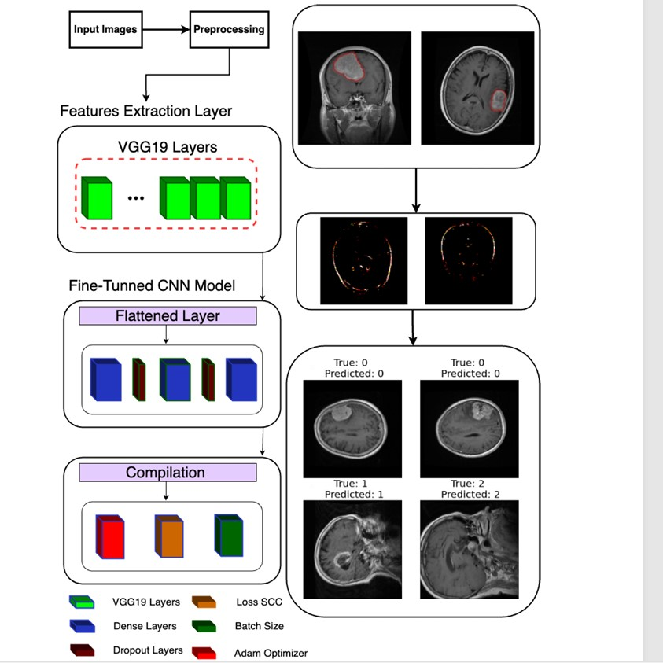
Figure 2.1:Classification model architecture (Alshomrani, 2024)

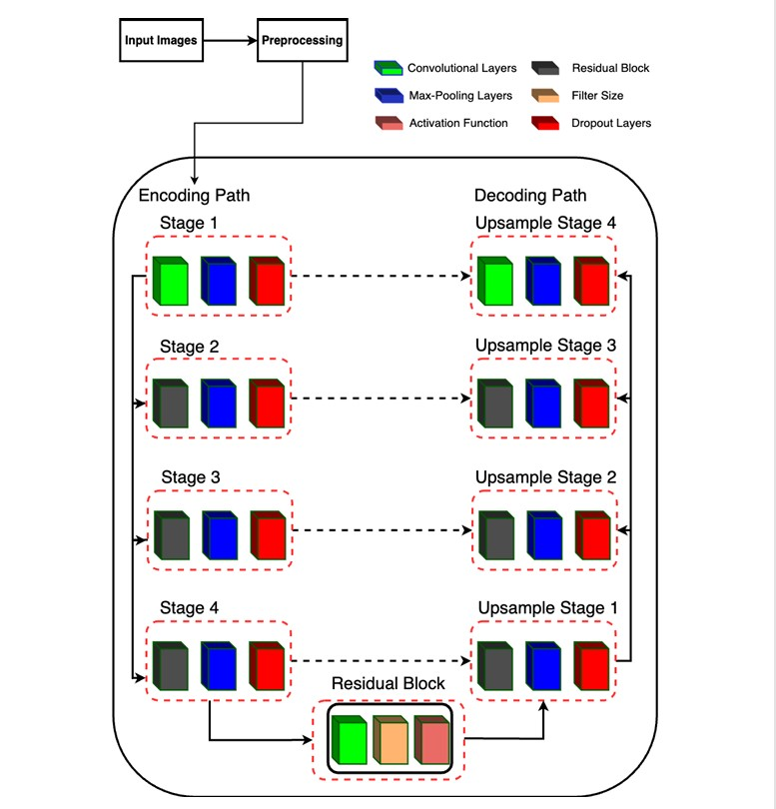
Figure 2.2:RUNet Architecture for segmentation (Alshomrani,2024)
The efficacy of the system was analysed using a comprehensive evaluation using multiple datasets. The primary dataset utilized, sourced from Figshare, comprises 3064 T1-weighted contrast-enhanced MRI images (Alshomrani, 2024). Each image in this dataset is accompanied by a corresponding ground truth mask, which serves as a reference for evaluating the accuracy of the segmentation mode.
The author conducted a rigorous performance evaluation of the pipeline. For the classification task, the metrics employed included loss, accuracy, confusion matrix, and classification report (Alshomrani, 2024). The proposed pipeline achieved an impressive accuracy of 96% for classification and 98.8% for segmentation on the Figshare dataset. To ensure the generalizability of the pipeline, it was further evaluated on two additional datasets: a four-class classification dataset with 7023 images and a two-class dataset with 3929 images for both classification and segmentation. The results demonstrated very good performance, achieving 95% accuracy on the four-class classification and high accuracy (96%) in the binary classification and segmentation tasks.
Although the systems produces high accuracy, there are several areas for potential improvement for example in the area of hyperparameter tuning the system relies on a random search for hyperparameter tuning (Alshomrani, 2024). A more systematic and rigorous approach, such as grid search or Bayesian optimization, could be employed to explore a wider range of hyperparameter combinations. This could lead to further improvements in both classification and segmentation performance.
Another area of improvement could be the integrating of this system with already existing clinical systems. A crucial aspect of translating research into clinical practice is the seamless integration of developed tools into existing healthcare systems. Future work should focus on validating the pipeline's compatibility with clinical workflows and data formats, ensuring its practical usability within a real-world medical setting. Figure 2.3 shows a flowchart of the unified pipeline of the system.

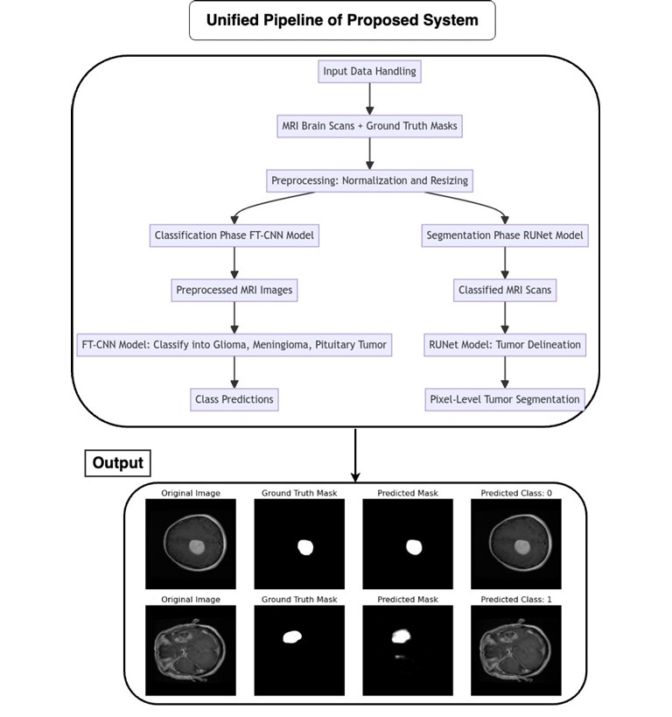
Figure 2.3: Proposed framework for the unified pipeline system (Alshomrani,2024)

2.6.2 Review of the NeuroImaging Sequence Examiner (NISE) application
NISE, which stands for NeuroImaging Sequence Examiner, is a 12-class classification app designed to identify brain MRI sequences and their orientation (Hua et al., 2023). The app utilizes the MobileNetV2 architecture and accepts various image formats, including Joint Photogrpahics Expert Group (JPEG), Portable Network Grpahics (PNG), Digital Imaging and Communications in Media (DICOM) slices, and NIfTI whole-brain volumes. NISE can distinguish between T1-weighted, T2-weighted, Proton Density, and Fluid-Attenuated Inversion Recovery sequences in axial, coronal, and sagittal orientations, it contains MobileNetV2 trained on 12 classes (Hua et al., 2023).
NISE addresses the issue of inaccurate or missing metadata information in MRI data, particularly in research settings where DICOM tags are often removed for anonymity. This is especially crucial when specific MRI sequences are required for developing Computer Aided Diagnosis tools. NISE automatically classifies the sequence type and orientation, ensuring accurate data management and facilitating the development of targeted diagnostic tools.
While NISE demonstrates promising capabilities, there are areas for further enhancement such as incorporating multi-tasking. Drawing from the multi-task learning approaches discussed previously, NISE could be enhanced to perform additional tasks concurrently with sequence identification. For example, it could be trained to detect specific pathologies or anatomical anomalies within the MRI images, providing a more comprehensive analysis (Hua et al., 2023).This would require careful consideration of loss balancing strategies to ensure optimal performance across all tasks.
Another area of improvement includes cloud integration for continuous updates. Utilizing cloud platforms like google firebase, could allow for the deployment of updated NISE models to users in real-time. This would ensure users always have access to the reinstallation, facilitating a more dynamic and adaptable system. By implementing these improvements, NISE could become an even more powerful and versatile tool for medical imaging analysis, contributing to improved diagnosis and patient care. The Figure 2.4 shows the interface of the NISE and the NeuroImaging Volumetric Extractor (NIVE) application.
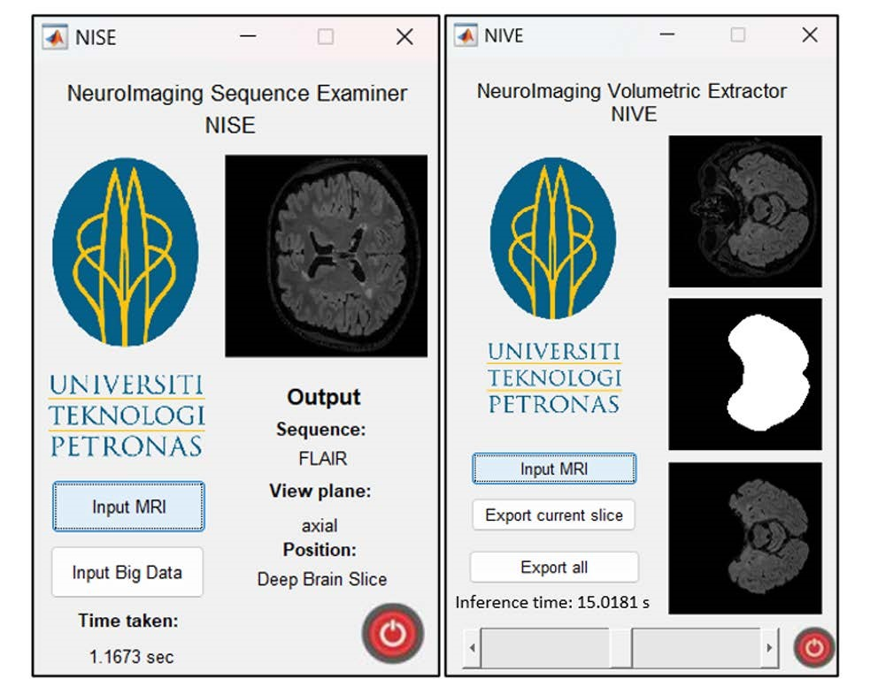Figure 2.4:Interface and output of the NISE and NIVE app (Memon et al., 2024)

2.7 Gaps Identified in Literature
While the reviewed studies demonstrate various approaches to multi-task learning (MTL) and loss balancing in medical image processing, they reveal several gaps in the literature concerning loss balancing methods and architectures for multi-task learning (MTL). While MTL offers potential benefits over single-task learning by leveraging shared knowledge across tasks, effectively balancing task contributions and optimizing information sharing remain active areas of research (S. Zhai et al., 2024).
One gap lies in the limited exploration of static loss balancing methods in the context of MTL. Although the sources categorize traditional algorithms in cloud computing as static, this classification is not extended to loss balancing techniques for machine learning (Lin et al., 2023). Static loss balancing, involving fixed weights assigned to each task's loss throughout training, contrasts with adaptive methods that dynamically adjust weights based on factors or variables discovered during training, including: task performance, uncertainty, or gradients. Even though static loss balancing methods are relatively simple, they have not received much attention in literature, leaving their effectiveness and potential benefits unexamined.
While the papers mention various approaches, including uncertainty weighting (UW) (Song et al., 2022), dynamic weight average, and impartial multi-task learning (Lin et al., 2023), they acknowledge that these methods often fail to achieve satisfactory results. Many existing approaches struggle to prevent one task from dominating the learning process, leading to uneven performance across tasks. This limitation highlights the need for more robust and adaptive loss balancing techniques that can effectively handle the complexities of task relationships in MTL.
During the course of the literature review, various limitations in typical ML architectures were pointed out especially, hard and soft parameter sharing (Zhai et al., 2024). Even though hard parameter sharing is simple and effective it can be less accurate when task relationships are conflicting. While soft parameter sharing, is prone to scalability issues as the number of tasks increases (Zhai et al., 2024). The paper exploring PS-MTL-LUCAS for soil property prediction proposes a partially shared architecture to address these limitations. However, finding the optimal balance between shared layers and task-specific layers remains an area for further exploration. This gap in the literature shows the need to develop innovative MTL architectures that can take advantage of task relationships while ensuring scalability and good performance across different tasks.
Finally, the papers reviewed show the importance of integrating domain-specific knowledge and considerations into the design of MTL models. In the paper focusing on brain tumour classification and segmentation, the authors emphasize the need to evaluate MTL models with expert radiologists to measure their accuracy and real-world applicability (Rabby et al., 2024). Similarly, the discussion on soil property prediction acknowledges the importance of balancing model performance with the practicality of data acquisition, suggesting the need to consider the cost and dimensionality of Vis-NIR spectroscopy data (Rabby et al., 2024). These insights suggest a gap in the literature concerning the integration of domain-specific knowledge into MTL model development and evaluation. This includes understanding the unique challenges and limitations within specific application areas, such as healthcare in order to tailor MTL models for real-world deployment and ensure practical use.

2.8 Summary of Literature Review
The papers reviewed in this chapter exhaustively explore the domain of multi-task learning as well as the various loss-balancing techniques that can be applied to it. Multi-task learning is a very broad field; therefore it is impossible to exhaust all existing literature. The works reviewed in this chapter focus on the problem of balancing task-specific losses during the training of a multi-task model. These studies highlight many methods of solving this problem including dynamic weight adjustment, uncertainty weighting, gradient normalization, dual balancing and experimenting with different model architectures to achieve an optimal balance (Hervella et al., 2024).
The literature review also identifies some gaps in our current understanding of multi-task learning and loss balancing. Even with the many existing approaches to task balancing, achieving consistently accurate results across all tasks remains a problem. This emphasizes the need for a more adaptable and dynamic approach that can handle the complex relationships between tasks. Additionally, the review emphasizes the importance of real-world practical considerations. For example, in medical applications, multi-task learning models should be evaluated in collaboration with medical experts to ensure reliability and interpretability.

CHAPTER THREE
SYSTEM ANALYSIS AND DESIGN

3.1 Preamble
This chapter describes the analysis and design of the system. It describes the requirements for the system, the techniques taken to achieve the system as well as diagrams to model the system. This is presented as a flowchart shown in Figure 3.1.
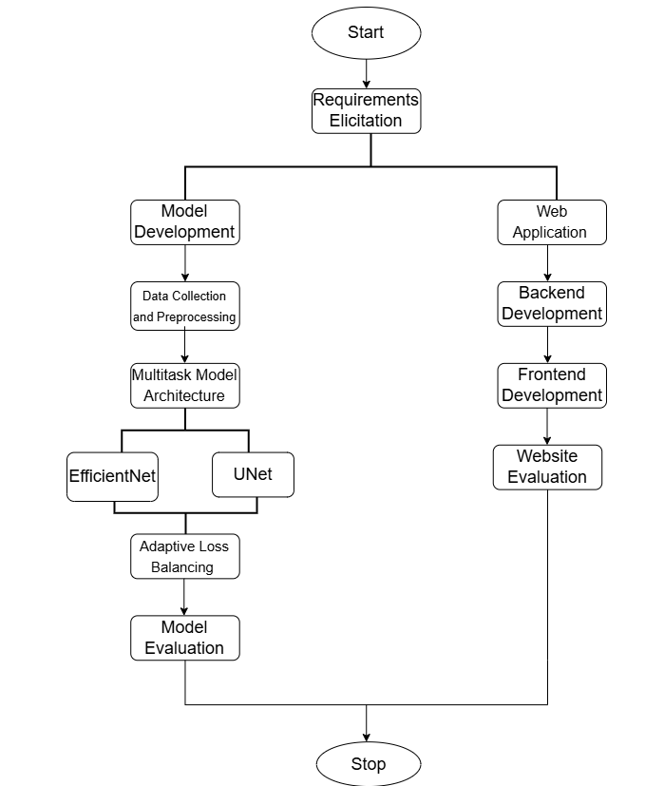
Figure 3.1:Project Workflow

3.2 Requirement Analysis
Requirements analysis, also referred to as requirements engineering involves the collection, examination and documentation of the features of a software system. Software requirements describe what the system should and should not do as well as the limitations or conditions under which it must operate. This chapter outlines the specific requirements for this project.

3.2.1 Functional Requirements
This refers to the functionality to be provided by the system. These requirements are as follows:
- The system should authenticate prospective users.
- The system should classify MRI images into different tumour types.
- The system should accurately segment tumour regions in the MRI images.
- The system should perform both classification and segmentation tasks simultaneously.
- The system should provide both the predicted tumour type and the segmented tumour mask for each input image as output.

3.2.2 Non-Functional Requirements
This refers to the constraints and limitations a system operates under. They are as follows:
- The system should provide results in a timely manner to aid efficient diagnosis.
- The system should have high availability in order to support medical staff around the clock with diagnosis.
- The system should be secure and keep patient information confidential.

3.3 Model Development
The main aim of this project was to develop a multi-task deep learning architecture capable of learning to classify and segment brain tumours from MRI scans. The following sub headings in this section detail the step by step methodology taken to build the multi-task model and integrate it into a functional web application.

3.3.1 Data Collection and Pre-processing
This section details the data sources, pre-processing procedures, and dataset preparation methods used to ensure that the model could accurately perform both classification and segmentation tasks. To effectively train the multi-task model for both classification and segmentation of brain tumours, a Comma Separated Value (CSV) file comprising of brain MRI images, corresponding segmentation masks, and classification labels was prepared and used to train the model. The data collection process involved sourcing from two standard publicly available datasets, followed by a series of pre-processing steps to ensure consistency during model training.

3.3.2 Data Sources
To achieve the dual task of classification and segmentation, two standard datasets were used:
- BraTS 2020 Dataset: The BraTS 2020 dataset is sourced from the Brain Tumour Segmentation Challenge (BraTS), this dataset consists of high-resolution 3D MRI volumes with expert annotated tumour segmentation masks. For this project, axial slices from the T1ce (contrast-enhanced) modality were extracted and converted into 2D images, which are suited for training a 2D U-Net for semantic segmentation. The segmentation masks are binary, marking tumour versus background at the pixel level.
- Figshare Brain MRI Dataset: This dataset contains over 3,000 2D MRI images labelled into four categories: glioma, meningioma, pituitary tumour, and no tumour. Each image is already labelled at the image level, making it ideal for training the classification branch of the model. Although the images vary in size and appearance, they have been curated for clarity and balanced class distribution.

3.3.3 Metadata Compilation
To align both segmentation and classification information, a consolidated CSV file named updated_labelled_dataset.csv was created. Each row in the CSV includes:
- image_path: the file path to the MRI slice.
- mask_path: the file path to the corresponding segmentation mask (for BraTS dataset).
- label: the label indicating the category type the tumour falls in (for classification).

3.3.4 Dataset Splitting
The dataset was divided into three parts:
- Training Set (70%): Used to fit the model and update weights.
- Validation Set (15%): Used during training to monitor model generalization and prevent overfitting.
- Test Set (15%): Held out for final model evaluation.
This division was performed using train_test_split from the sklearn.model_selection module. The random seed was fixed (random_state=42) to ensure reproducibility across training runs and maintain consistent data splits. Dataset splitting was also done to prevent the multi-task model from overfitting.

3.3.5 Pre-processing and Augmentation Pipeline
Before the data was loaded into the model, extensive pre-processing was applied to standardize image dimensions, increase diversity, and reduce overfitting:
- Image Resizing: All MRI images and corresponding masks were resized to a fixed dimension of 256×256 pixels using the transforms.Resize() function. This uniform size allowed for consistency during training and it matched the training requirements of the SwinUnet model.
- Normalization: Image tensors were normalized to the range [-1, 1]. Normalization speeds up convergence by standardizing the input distribution, which benefits gradient-based optimization.
- Data Augmentation: To increase dataset diversity and robustness, the following augmentations were applied:
  - Random Horizontal and Vertical Flips: Simulate different orientations.
  - Random Rotations (±30°): Introduce variability in angle and position.
  - Colour Jittering: Adjust brightness, contrast, saturation, and hue, although this had minimal effect given the grayscale nature of MRI scans.
  - These augmentations were implemented using PyTorch’s torchvision.transforms.Compose() pipeline and were applied consistently to both images and masks during training.
- Conversion to Tensors: Both images and masks were converted into PyTorch tensors using transforms.ToTensor(). This step is crucial for model compatibility and Graphics Processing Unit (GPU) acceleration.
- Mask Clipping: Post-transform, the mask pixel values were clamped to [0, 1]. This ensures binary representation, as expected by the segmentation loss function.

3.4 Multi-task Model Architecture
The system is built upon a multi-task deep learning architecture, designed to simultaneously perform tumour classification and tumour segmentation on 2D brain MRI slices. Unlike traditional single-task networks, this architecture utilizes a shared backbone and two task-specific branches, enabling shared representation learning. This not only reduces training time and computational cost but also leads to improved generalization due to the mutual reinforcement of related tasks.
The model takes a single input, a pre-processed MRI slice and produces two outputs including a segmentation mask, identifying the exact tumour region in the image and a class label, categorizing the tumour as either glioma, meningioma, pituitary tumour, or no tumour. The core of the architecture consists of two primary components, EfficientNet-B0 which was used as the classification branch and U-Net which was used as the segmentation branch. These two branches are trained at the same time using a shared input and the adaptive loss balancing algorithm. Figure 3.2 is a diagram showing the architecture behind the multi-task model used.

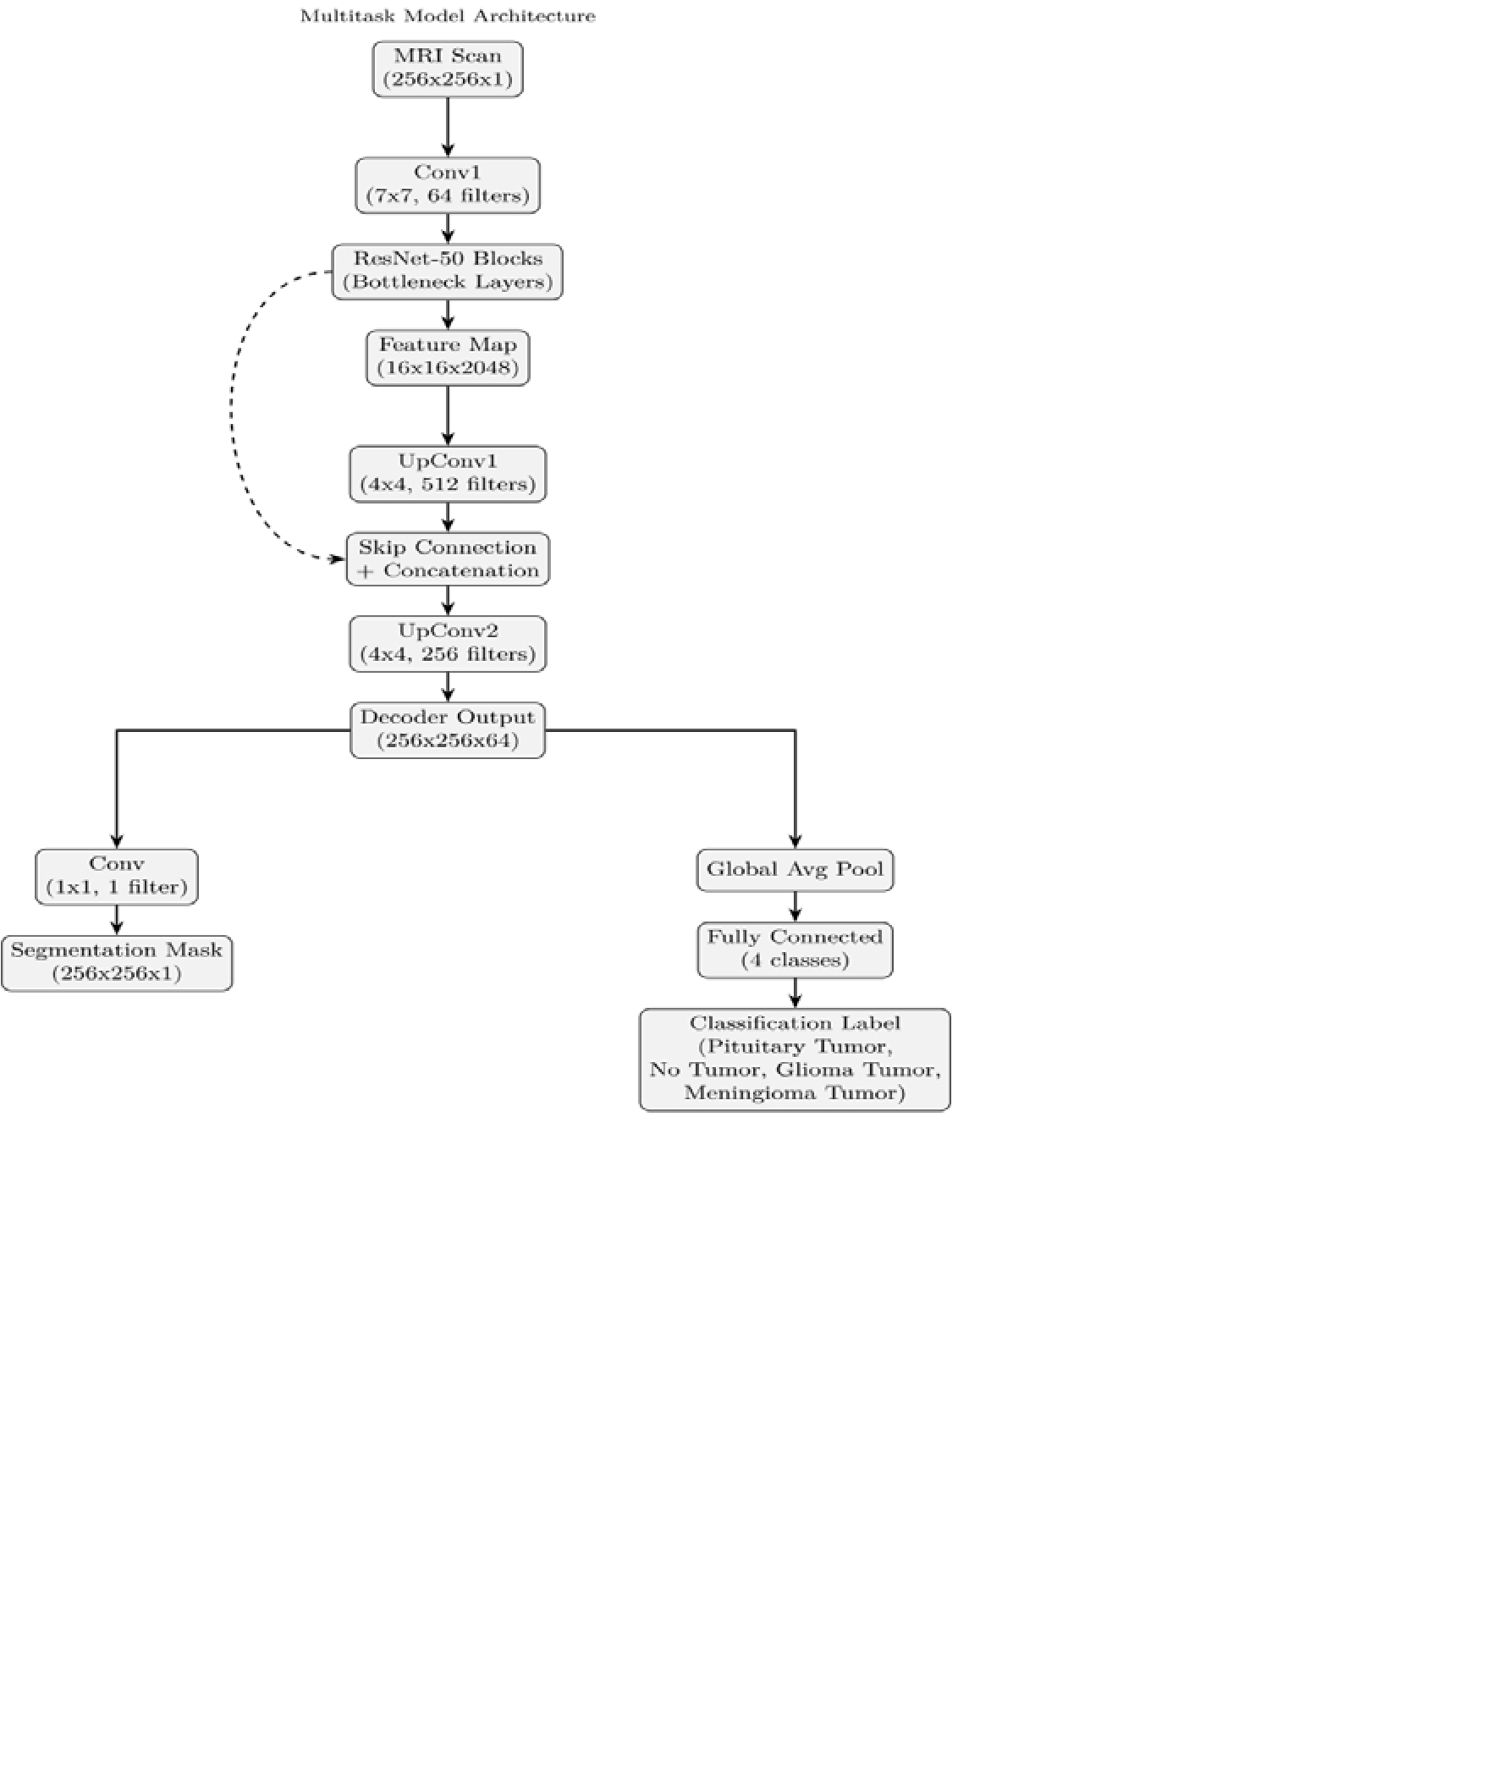
Figure 3.2:Multi-task Model Architecture

3.4.1 EfficientNet (Classification Branch)
EfficientNet-B0 served as the base classification model because of its optimality in terms of performance and lightness. As opposed to conventional CNNs, EfficientNet applies a compound scaling method that concurrently scales up the network's depth, width, and input resolution. Using this new scaling method, it can achieve greater accuracy using fewer parameters and less computation expense, which makes it highly suitable to deployment in GPU memory-limited environments.
In this project, the pre-trained EfficientNet-B0 model available in PyTorch’s torchvision model zoo was used. To modify it to the specific task, the final classification head of the model was modified to output four logits, corresponding to the four different tumour types targeted in the classification task.
To enhance learning and decrease training time, transfer learning was utilized. The early layers of the model that have learned universal image features were frozen, and the later layers were fine-tuned with labelled MRI images. This allowed the model to learn the domain-specific features of brain tumours without wasting the helpful general features learned from large-scale image datasets.
EfficientNet-B0 was incorporated into the whole pipeline of the multi-task learning project. It received the same pre-processed image inputs as the U-Net model being employed for segmentation. In this architecture, EfficientNet was tasked with making high-level predictions of tumour classification and augmenting the semantic segmentation provided by the segmentation branch.

3.4.2 SwinUnet (Segmentation Branch)
The segmentation task for this project was tackled with a transformer model from the MONAI library, which is a library dedicated to medical imaging. SwinUnet is particularly suited for medical image segmentation because it is an encoder-decoder model and also has skip connections that enable it to retain spatial features that are important for accurate segmentation. These architectural merits place it in a good position for tumour segmentation from MRI images.
In this implementation, the segmentation arm of SwinUnet received the same pre-processed input images used by the classification arm. The encoder part of the network is composed of a sequence of convolutional blocks with ReLU activations, interposed by downsampling methods like strided convolutions and max pooling in order to progressively decrease spatial dimensions and capture high-level features. Meanwhile, the decoder pathway recovers spatial resolution through transposed convolutions and upsampling blocks.
A defining feature of SwinUnet is the use of skip connections that directly link corresponding encoder and decoder layers. These connections allow spatial information lost during down sampling to be reintroduced during upsampling, improving the precision of the final segmentation output. The model’s output consists of a single-channel mask, which is passed through a sigmoid activation function. Pixel values greater than 0.5 are interpreted as tumour regions, while values below this threshold are considered background.
The model was initialized with randomly assigned weights and trained using a combination of dice loss and focal loss. These losses are particularly effective for medical segmentation tasks, as it addresses the issue of class imbalance by focusing on the overlap between predicted and ground-truth tumour regions, rather than relying solely on pixelwise accuracy.

3.5 Adaptive Loss Balancing Function
This project implemented an adaptive loss balancing algorithm during model training to ensure that both the segmentation and classification task were receiving equal attention during training and were both performing optimally. The algorithm works by dynamically adjusting task-specific losses based on uncertainty weighting. The following sections describe the objective, structure, implementation, and effectiveness of this adaptive loss strategy as applied in this project.

3.5.1 Objective of the Adaptive Loss
In the multitask model environment, the segmentation and classification task each have their own loss functions. The losses from these two tasks converge at different rates so the objective of the loss balancing was to learn optimal weighting factors for each task’s loss, allowing both tasks to contribute meaningfully during training. This approach eliminates the need for manual tuning of loss weights and promotes a more stable and effective joint optimization of the network

3.5.2 Structure of the Combined Loss Function
The total loss used in this project combines two components: the dice loss and focal loss for the segmentation task and categorical cross-entropy loss for the classification task. These are weighted using two trainable parameters, logσ₁ and logσ₂, which represent the log uncertainties of the segmentation and classification tasks, respectively. The total loss is defined in Equation 3.1 as:
$$L_{total}=\exp\left(-logσ_{1}\right)×L_{seg}+logσ_{1}+\exp\left(-logσ_{2}\right)×L_{cls}+logσ_{2}$$ | (3.1)
Here, $L_{seg}$ refers to the Dice Loss between the predicted and ground truth masks, while $L_{cls}$ denotes the Cross-Entropy Loss between the predicted logits and the true class labels.
A regularization constant _{λ} was introduced and set to 0.01 to ensure numerical stability and meaningful contributions from both tasks. This formulation allows the model to focus more on the task with higher uncertainty at any point during training.

3.5.3 Implementation Details
The adaptive loss function was implemented in a separate AdaptiveLoss class with PyTorch. Both log uncertainty parameters were created as trainable variables within the model class. These were fed to the loss function and backpropagated through backpropagation along with model weights. The log_sigma1 and log_sigma2 values were clamped to a specific range to ensure stability during training. This provided numerical stability and kept the adaptive weights from growing very large or very small, which would produce unstable training dynamics.

3.5.4 Regularization Strategy
To further promote balanced learning, a regularization term was incorporated into the total loss. This term, defined as λ (logσ₁² + logσ₂²), penalizes excessive scaling of the uncertainty parameters. This discourages the model from favouring one task over the other and encourages equal and consistent contributions from both classification and segmentation throughout the training process.

3.5.5 Outcome and Effectiveness
The adaptive loss balancing algorithm was utilized effectively to balance the training of the two tasks. At initial phases of training, segmentation loss dominated and thereby enabled the model to learn spatial boundaries that are needed for precise tumour delineation. At later stages of training, classification loss started dominating increasingly and thereby resulted in balanced optimization within the two branches. This adaptive approach resulted in better convergence behaviour, more stable learning curves, and superior final performance metrics for both the classification and segmentation tasks.

3.6 Model Training and Evaluation
The multi-task model was trained in an end-to-end manner to ensure optimization. This approached ensured that the model could learn to categorize tumour types(classification) and accurately segment tumour regions (segmentation) in a unified framework. The adaptive loss balancing algorithm was also incorporated during model training.

3.6.1 Training Configuration
To facilitate effective learning, a set of carefully selected training hyperparameters and techniques were applied:
- Optimizer: The multi-task model made use of the Adam optimizer, which was chosen because of its adaptive learning rate.
- Learning Rate: The learning rate was initially 0.001. It was chosen to provide a compromise between training convergence and stability.
- Weight Decay: Weight decay of 1×10⁻⁴ was applied to prevent overfitting. This is L2 regularization that discourages very large weights and aids generalization.
- Learning Rate Scheduler: A step-based learning rate scheduler (StepLR) was applied, which reduces the learning rate by a factor of 0.1 every five epochs. Gradual decay aids smaller weight updates as training proceeds, which helps achieve convergence.
- Epochs: The model was trained over 70 complete iterations of the training dataset. This number was determined based on the available computation time and the need for timely convergence.
- Batch Size: A batch size of 8 was used, balancing the available GPU memory constraints with the need for stable gradient estimates during optimization.
All training was conducted using the Pytorch framework and leveraged GPU acceleration via CUDA when available. This setup enabled efficient handling of large image data and accelerated model computations.

3.6.2 Training Process
During each epoch of training, the model underwent a structured procedure to ensure consistent optimization. The model was first set to training mode, enabling features such as dropout and batch normalization to function appropriately. For each batch, pre-processed MRI slices, their corresponding ground truth segmentation masks, and tumour type labels were retrieved from the training DataLoader. These inputs were passed through the multi-task model, which simultaneously produced the predicted segmentation output, classification logits, and the two learnable parameters that controlled the uncertainty-based loss weighting.
The adaptive loss function was then used to compute a single total loss value by balancing the segmentation and classification losses. This dynamic weighting ensured that both tasks contributed effectively during training. After calculating the loss, backpropagation was applied to compute gradients, and the optimizer adjusted the model's weights accordingly. Following the update, the learning rate was adjusted using the StepLR scheduler to refine the optimization process over time.

3.6.3 Validation and Monitoring
At the end of each epoch, the model was evaluated using a separate validation set to monitor its generalization performance. During this phase, gradient computation was disabled to reduce memory consumption and speed up inference. The adaptive loss function was again applied to compute validation loss, allowing a direct comparison with training loss. This monitoring helped identify signs of overfitting and provided a basis for implementing early stopping strategies if necessary. While the model was training, test images were used to validate that the model was producing the correct output as shown in Figure 3.3.
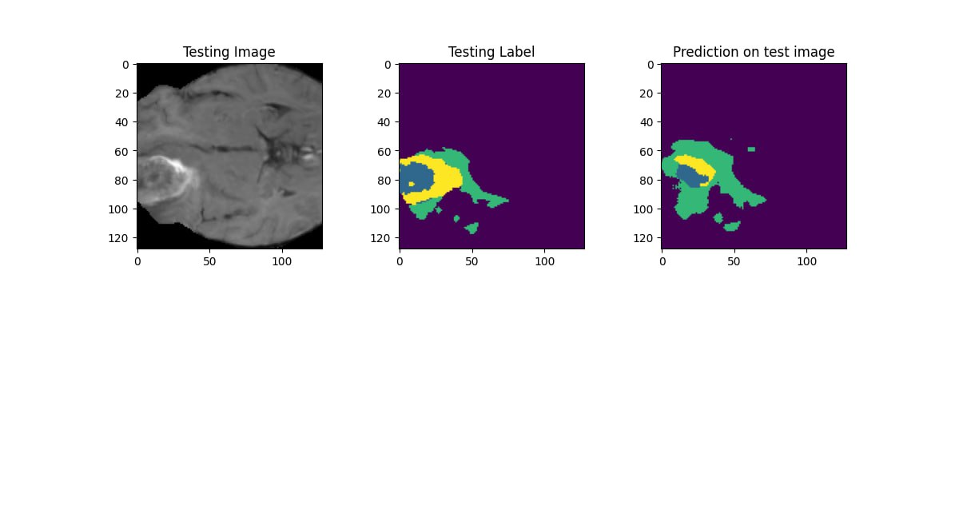Figure 3.3: Testing Image

3.6.4 Evaluation Metrics
To assess the final performance of the model, evaluation was conducted on a held-out test set using two primary metrics. For the segmentation task, the IoU Score and accuracy score was used to measure the overlap between predicted and ground truth tumour regions, which is especially important in medical imaging due to class imbalance. For the classification task, overall accuracy and F1 score was used to evaluate how correctly the model predicted tumour types. These metrics provided a comprehensive assessment of the model’s ability to both segment and classify tumours.

3.7 Web Application Development
The multi-task model was integrated into a web application with a user-friendly interface where users can upload MRI images and receive classification and segmentation results in real time. The web application is made up of a Flask backend and a React.js frontend.

3.7.1 Flask Backend
In order to host the trained multi-task model for real-time prediction, a backend system was built upon Flask, which is a Python web framework that is nicely lightweight and ideal for machine learning model hosting. The backend was built to expose an API called /predict that takes MRI scans, runs inference with the trained model, and returns predicted tumour class and segmentation mask. There were five major functional modules in the Flask backend:
- Flask Server: The central web application that waits for incoming requests and routes them to the proper handlers.
- Model Loader: Upon start up, the backend loaded the trained multi-task model from disk and placed it onto the correct computation device (CPU or GPU) for inference.
- Pre-processor: This module made sure that any image coming in from the MRI was processed by the same pre-processing chain of resizing, normalization, and conversion to tensor that was used while training the model.
- Inference Engine: The image was then passed into the model to produce two outputs: segmentation mask defining areas of tumour and classification logits for predicting tumour type.
- Post-processor: This component applied final transformations to the raw model outputs. The segmentation mask was thresholded to produce a binary image, and the classification logits were converted into probabilities using the softmax function. These processed results were prepared for easy interpretation and frontend integration.
The backend provided a single prediction endpoint, accessible via a POST request to /predict. This endpoint was responsible for handling incoming MRI image files. When a request was received:
- The image was extracted from the request payload and converted to a tensor.
- The model was called to perform a forward pass using the pre-processed image.
- The classification output was processed to yield the predicted class label with corresponding confidence scores.
- The segmentation output was converted into a binary mask that visually delineated the tumour area.
- Both results were packaged into a structured JSON response, enabling seamless communication with the frontend.
This backend architecture allowed the system to support real-time tumour detection and classification within a reasonable processing time, serving as the interface between the multi-task model and the web application.

3.8 Frontend with React
The frontend application was developed using React, a widely-used JavaScript library for building responsive user-friendly interfaces. It served as the primary interaction point between the user and the trained model, allowing for real-time MRI image analysis. Tailwind Cascading Style Sheets (CSS) was used to design the components of the website and make it responsive to different web browsers and device sizes. The React interface was designed to handle the following core functionalities:
- Image Upload and Preview: Users could upload an MRI image and view it prior to submission. This ensured input verification and provided immediate visual feedback.
- Inference Result Display: Once the image was submitted, the backend returned the predicted tumour class along with its confidence score, and a segmented mask overlayed on the uploaded image.
- Error Handling and Feedback: The application displayed appropriate messages in case of unsupported file formats, server errors, or failed predictions.
State management was achieved using React Hooks, specifically UseState and UseEffect. The UseState hook tracked the uploaded image, the model’s response, and interface messages, while UseEffect was used to trigger side effects such as API calls after image submission. These hooks ensured smooth user interactions and dynamic rendering of results without the need for page reloads.
By combining React with Tailwind CSS, the frontend achieved a high level of responsiveness and usability, making it suitable for deployment even on lower-end devices. The minimalistic design, fast interaction feedback, and real-time result visualization contributed to a seamless user experience.

3.8.1 UML Modelling
To represent the system's behaviour, functionality, and data structure, several models and diagrams were used, The following user modelling diagrams depict the user’s interaction with the website.
- Use Case Diagram: This is an illustration of the interactions between actors and the system that is being developed. It facilitates the definition of the system's boundaries as well as its functional requirements. Use cases represent certain functionality or behaviors, whereas actors represent the entities interacting with the system. The users of the system are depicted as stick figures, and the use cases are depicted using ellipses. Actors are linked to use cases by lines or arrows, which display their connections and relationships. Figure 3.4 shows the use case diagram of the system.
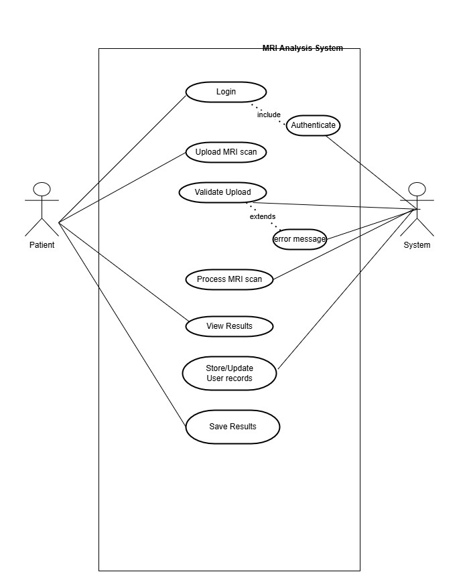
Figure 3.4: Use Case diagram
- Activity Diagram: An activity diagram is a pictorial representation that depicts how a system or a particular workflow's activities or processes flow. They offer a high-level overview of the steps necessary to complete a process or reach a certain goal, together with the circumstances and decisions that have an impact on the flow. Activities and the flow of control between these activities are represented in activity diagrams using a variety of symbols, such as nodes and arrows. A representation of the activity diagram of this system is shown in Figure 3.5.
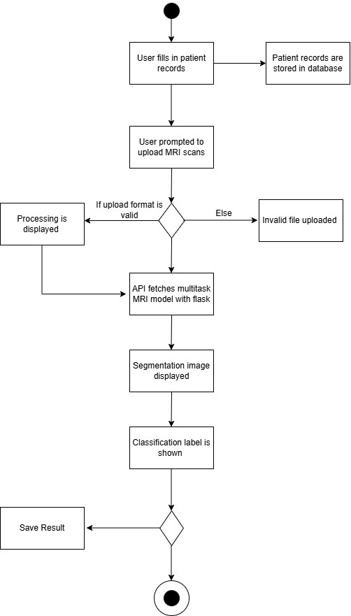
Figure 3.5: Activity Diagram

3.9 Website Evaluation
To evaluate the usability of the developed website interface, a structured questionnaire was administered based on the Post-Study System Usability Questionnaire standard. The PSSUQ is a standard instrument used to measure user satisfaction across three key metrics including: system usefulness, information quality, and interface quality. The questionnaire was administered online using google forms
The evaluation was conducted in a clinical setting, involving a sample of healthcare professionals and/or domain experts who represented the target end users of the system. This setting provided realistic feedback on the usability and effectiveness of the system in a real-world medical environment. Responses were collected anonymously and analysed quantitatively using standard Likert-scale interpretation to measure usability satisfaction.

CHAPTER FOUR
SYSTEM IMPLEMENTATION AND EVALUATION

4.1 Preamble
This chapter focuses on the implementation of the MRI segmentation and classification multi-task model. It presents the hardware and software requirements needed to develop and make use of the system as well as the development methodology, program modules and interfaces and the evaluation of the system.

4.2 System Requirements
This refers to the required standards and functionality the system must possess to meet the user’s needs. It consists of the hardware requirements and software requirements.

4.2.1 Hardware Requirements
These requirements are the necessary hardware specifications for running the software system. It also includes the minimum required hardware resources to train the model used in the system. The hardware requirements for the project are detailed in Table 4.1.

Table 4.1: Hardware Requirements Table
S/N | REQUIREMENT | HARDWARE
1. | Processor | Intel core i7 or higher/ Apple M1 chip
2. | Primary Memory | 32 GB RAM (Random Access Memory) or higher
3. | Architecture | 64Bit (X64) for windows /  ARM X64
4. | Secondary Storage | 32GB HDD or higher

4.2.2 Software Requirements
These requirements are necessary for running the software system successfully. They must be pre-installed and set for the intelligent auto-response system to run smoothly. Table 4.2 details the software requirements.

Table 4.2: Software Requirements Table
S/N | REQUIREMENT | SOFTWARE
1. | Operating System | Mac OS: v11.0.0 or higher  Windows: 10 or higher  Linux: Ubuntu
2. | Programming Language | Python3, React.JS, Tailwind,
4. | Development Tool | Visual Studio Code, Github
5. | Supported browser | Google Chrome, Safari

4.3 Implementation Tools
These are the tools utilised while building the software project. They helped to ensure the successful development of the MRI segmentation and classification multi-task model.

4.3.1 Python
Python is the core programming language utilised for this project. It is an object-oriented general purpose programming language with strong applications in the field of Data Science and Machine Learning as well as Web Development. Python was used to build the backend and the handle the training and fine-tuning of the multi-task model. As a result of its wide acceptance and large community support, Python has several useful libraries and frameworks. Some of the Python libraries utilised in this project include Pandas, numpy, sklearn, PIL(for image loading), Flask (a web development framework).

4.3.2 React
React is a JavaScript library used for building the frontend user interface of the application. It was used to design the various components that made up the frontend of the web application. The interface built using React provides a user-friendly way to upload MRI scans, view results, and save them in real time.

4.3.3 Visual Studio Code
Visual Studio Code is the development environment used throughout the development of the project. It was useful throughout coding because it uses IntelliSense and provides features such as syntax highlighting, debugging, and Git integration, which improved productivity and code quality.

4.3.4 Github
GitHub was used for version control and collaboration. It allowed tracking of changes, backup of code, and efficient collaboration with supervisors or contributors. GitHub also facilitated continuous integration and deployment readiness by organizing the project into manageable commits and branches.

4.3.3 Tailwind CSS
Tailwind CSS is a CSS framework used alongside React for styling the frontend. It provides low-level utility classes that enable rapid and consistent styling of components without writing custom CSS. This helped maintain a clean, responsive, and modern design across the web interface.

4.4 Development Methodology
The development methodology used for this project is the Iterative Waterfall model. This approach combines the traditional Waterfall model with the flexibility of Agile practices. Like the Waterfall model, stages such as requirements gathering, data preparation, model design, training, and evaluation are carried out sequentially. However, the iterative component allows for returning to earlier stages when necessary, especially useful in machine learning projects that require frequent refinement and experimentation.
At the start, the project followed a linear path: identifying objectives, sourcing data, and defining a multi-task architecture capable of both tumour segmentation and tumour type classification. However, during model development, it became clear that earlier decisions, such as how the data was pre-processed or how the loss functions were weighted ,needed to be revisited. Model training required extensive experimentation, including fine-tuning the shared encoder, adjusting hyper-parameters, and rebalancing the segmentation and classification branches. The Iterative Waterfall model was ideal in accommodating these repeated improvements without disrupting the overall structure of the project.
The key phases of this methodology as applied to the project are outlined below:
- Project Initiation: The project began with the identification of a medical imaging problem that required a multi-task solution, tumour segmentation and classification from MRI scans. The goals and expected outcomes were clearly defined, and relevant research literature and datasets were reviewed.
- Project Planning: The planning phase involved selecting the model architecture (a shared encoder with separate segmentation and classification heads), tools (such as PyTorch, NumPy, and OpenCV), and resources (including GPU access). The structure of input data and expected outputs for both tasks were also clearly mapped out.
- Project Execution: MRI data and corresponding tumour masks and labels were pre-processed, resized, normalized, and organized into suitable training and validation sets. The model architecture was implemented, integrating a dual-output design for handling both segmentation maps and class predictions simultaneously.
- Iterative Development: After initial training, several iterations were made to improve performance. This included adjusting learning rates, trying different loss combinations (e.g., Dice loss + CrossEntropy), refining augmentation strategies, and revisiting how data was split.
- Continuous Testing: Throughout the development, the model was evaluated using relevant metrics: Dice coefficient and IoU for segmentation, and accuracy,f1 score for classification. Performance results from each iteration informed the next round of adjustments.
- Repeat and Iterate: During the course of the project life cycle, results from the evaluation metrics were used to refine the model. This loop continued until both tasks achieved satisfactory performance levels.

4.5 Evaluation of the System
The multi-task model was evaluated using both classification and segmentation metrics. This was done to assess the capabilities of the model and to ensure that it was both accurately segmenting tumours as well as providing the correct labels for each tumour type.
The evaluation was conducted using a split of the dataset, after training the model using a custom loop for 70 epochs, the evaluation was performed separately on the test sets for classification and segmentation. Metrics such as accuracy, Intersection over Union (IoU), segmentation loss and classification loss were used to assess performance.

4.5.1 Evaluation Criteria
Six metrics were used to evaluate the performance of the two branches in the multi-task model. They are as follows:
- Classification Accuracy: This metric measures the amount of correctly classified MRI images against the total number of images in the test set. It shows the model’s ability to correctly identify the tumour type among the predefined classes (no tumour, glioma, meningioma, pituitary).
- Classification F1 Score: F1 score is the harmonic mean of precision and recall and it evaluates the model’s performance across the labelled categories. It provides a balanced measure of the model’s ability to correctly predict and generalize across all classes.
- Categorical Cross-Entropy Loss (Classification loss): Used to quantify the prediction error in the classification branch.
- Segmentation Intersection over Union (IoU) Score: Segmentation IoU measures the overlap between the segmented tumour region and the ground truth masks.
- Dice + Focal Loss (Segmentation Loss): Segmentation loss was calculated as a function of dice loss combined with focal loss and used to evaluate the model during training.
- Segmentation Accuracy: Which measures how well the model divided the images into segmented regions as compared to the ground truth masks.

During the training and validation stages these metrics were assessed and recorded on the test data to ensure the multi-task model was performing accurately.

4.5.2 Evaluation Results
Below are the final evaluation scores obtained on the test dataset after 70 epochs of training:
- Test Classification Accuracy: 98.15%
- Test Classification F1 Score: 0.973
- Test Classification Loss: 0.5462
- Test Segmentation IoU Score: 0.7624
- Test Segmentation Accuracy : 97.69%
- Test Segmentation Loss: 0.7922
The model achieved high classification accuracy, correctly predicting the tumour type during testing. Similarly, the segmentation branch achieved a good IoU score and a high segmentation accuracy, showing the capacity of the multi-task model to accurately delineate tumour boundaries in MRI images.

4.5.3 Graph Visualization
This section shows the performance of the multi-task model over 70 training epochs. The training progress of the multi-task model was visualized using graphs in order to provide insight into how the accuracy was increasing and how the losses for each task were converging. Figure 4.1 illustrates the accuracy trends, while Figure 4.2 captures the evolution of the loss function throughout the training process.
The accuracy graph shows a consistent improvement in both training and validation accuracy over the course of 70 epochs. Initially, there is a noticeable gap between the two curves, with validation accuracy fluctuating more significantly in the early stages. However, as training progresses, the model demonstrates consistent learning, with both curves converging towards an accuracy level above 98%. The alignment of training and validation accuracy in the later epochs indicates that the model has achieved good generalization performance and is not overfitting to the training data. This is shown in Figure 4.1.

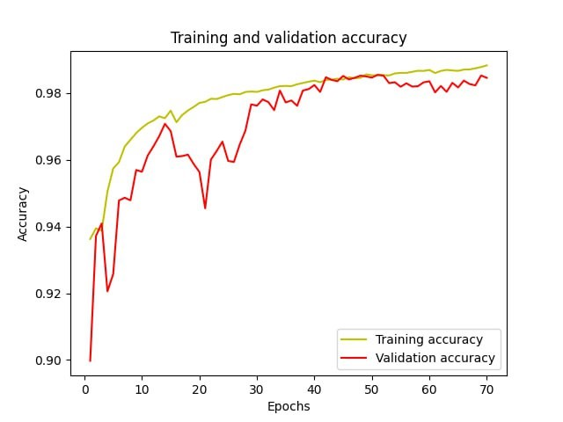
Figure 4.1: Accuracy graph visualization
The loss graph supports the information shown in the accuracy graph by presenting a constant decline in both training and validation loss across the epochs. The training loss exhibits a smooth downward trajectory, while the validation loss shows more variation in the earlier epochs before becoming stable around 40 epochs. This progressive reduction in loss highlights the model’s improved ability to minimize error on both datasets. The narrowing gap between training and validation loss further supports the observation that the model maintains a balanced performance without significant overfitting. This is shown in Figure 4.2 .

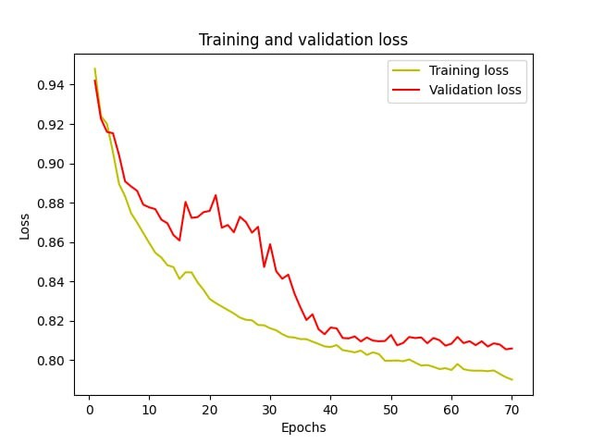
Figure 4.2: Training loss graph visualization

4.5.4 Benchmarking Against Existing Papers
To assess the effectiveness of the multi-task model incorporating an adaptive loss balancing algorithm, a comparative benchmarking was carried out against selected state-of-the-art multi-task learning models for tumour segmentation and classification. These baseline models were chosen based on recency, relevance, and their use of similar datasets or architectures, but without adaptive loss balancing. This comparison highlights the improvement in performance across the following metrics: classification accuracy, classification F1 score, segmentation IoU, and segmentation accuracy, due to the introduction of the adaptive loss balancing algorithm. Table 4.3 shows the results of the benchmarking.

Author | Adaptive loss | Classification  Accuracy | Classification F1 Score | Segmentation IoU | Segmentation Accuracy
Zarnia et al.(2025) | Not Used | 96.5% | 0.94 | 0.81 | 91.0%
Rabby et al.(2024) | Not used | 97.0% | 0.93 | 0.86 | 92.0%
Lin et al.(2023) | Hybrid balancing(gradient+  Weighted loss) | 97.0% | 0.92 | 0.80
MRI Segmentation and Classification Multi-task Model | Applied | 98.15% | 0.973 | 0.7624 | 97.69%
Table 4.3: Benchmarking Table

The results from the benchmarking show that this study’s multi-task model performs better in both classification and segmentation compared to existing multitask models that did not apply adaptive loss balancing. Despite some existing models achieving slightly higher segmentation IoU (e.g., Rabby et al. with 86%), the multi-task model excels in overall segmentation accuracy (97.69%), suggesting more consistent boundary delineation across all test samples.
Additionally, the classification performance of this study’s multi-task model is better than the existing studies, achieving 98.15% accuracy and a high F1 score of 0.973, compared to a maximum of 97% and 0.94 from prior approaches. This improvement can be attributed to the adaptive loss balancing strategy, which dynamically adjusts the influence of each task’s loss, leading to better optimization and learning stability.
The results from this benchmarking show that the addition of adaptive loss balancing in a multi-task architecture significantly enhances performance, especially in scenarios involving related tasks like segmentation and classification.

4.5.5 User Feedback and Usability Evaluation
To evaluate the usability of the system, the PSSUQ was administered to a group of 85 users. The questionnaire measures user satisfaction across various criteria, including system usefulness, information quality, and interface quality. It consists sixteen (16) questions, each rated on a 7-point scale ranging from Strongly Disagree to Strongly Agree. The results were:
- System Usefulness: 5.25/7
- Information Quality: 5.57/7
- Interface Quality: 5.70/7
- Overall Satisfaction: 5.57/7
These scores suggests that the system was well designed, user friendly and effective in meeting the users’ needs. The Interface Quality has the highest rating and this means that the users derived high utility from interacting with the system and were satisfied with their user experience. The overall satisfaction score suggests that the system was well received and performs well in terms of usability and user experience.

4.5.6 Discussion
The result obtained from the evaluation on the test dataset show that the multi-task model achieved a strong performance across both tasks. The model attained a test classification accuracy of 98.15% and a classification F1 score of 0.973, with a corresponding classification loss of 0.5462. This high accuracy highlights the model’s capability in correctly classifying tumour type into the pre-defined labels. The relatively low classification loss further confirms that the model generalizes well, with minimal overfitting observed during training, as supported by the training-validation accuracy trends. The adaptive loss balancing approach likely contributed to stabilizing classification learning even as the model simultaneously optimized the more challenging segmentation branch.
For the segmentation task, the model achieved a Segmentation IoU Score of 0.7624, Segmentation Accuracy of 97.69%, and Segmentation Loss of 0.7922. The IoU score, a more stringent metric than accuracy for pixel-level tasks, suggests that the model can capture tumour boundaries with reasonable precision. An IoU above 0.75 on complex MRI data is a promising result, especially considering that some tumour regions are difficult to segment due to noise, intensity variation, and anatomical differences across patients. The high segmentation accuracy (97.69%) reinforces that the model performs well at the pixel level across the whole image, while the moderate segmentation loss indicates that some areas of improvement remain, particularly for fine-grained boundary details.
The balance between classification and segmentation scores suggests that the adaptive loss algorithm successfully managed the trade-off between the two tasks. The training curves also support this: the validation accuracy and loss trends remained stable, with no severe overfitting or degradation on either task after 70 epochs. Achieving these results after only 70 epochs of training shows the model’s efficiency and capacity for fast convergence, which is important for practical deployments in clinical settings where retraining may be required frequently.
In conclusion, the multi-task model demonstrates a strong performance in both tasks. The results validate the effectiveness of the adaptive loss balancing algorithm in facilitating simultaneous optimization of two related but different tasks.

4.6 Program Modules and Interfaces
This section outlines the main components of the user interface developed for interacting with the multi-task tumour classification and segmentation model.

4.6.1 Authentication Page
The authentication page is the entry point for medical professionals to securely access the system. This page was designed to ensure confidentiality of patient records and prevent non-medical personnel from accessing and using the system. This page is shown in Figure 4.3.

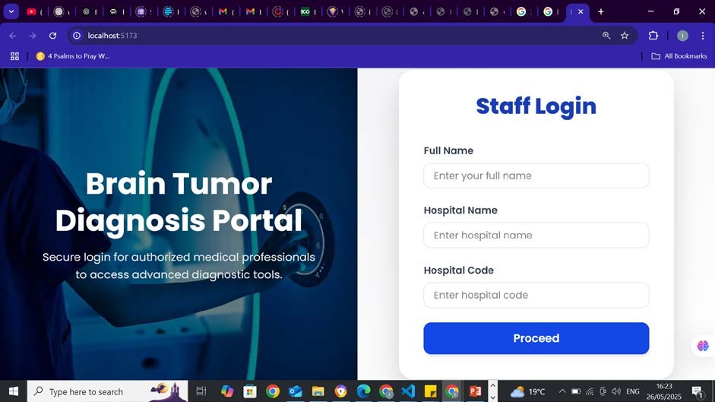
Figure 4.3: Authentication Page

4.6.2 Upload Page
The upload page is the core of the user interaction with the multi-task model. On this page, users are prompted to upload an MRI scan image file, either through drag and drop or by clicking the file upload background. Once uploaded, the model processes the scan and displays two outputs, a segmentation mask highlighting the detected tumour region and a classification label identifying the tumour type (e.g., glioma, meningioma, pituitary, or no tumour). The page also includes a Save Results button that enables users to download the segmentation image output for record-keeping and further analysis. The upload page is shown in Figure 4.4 and Figure 4.5.

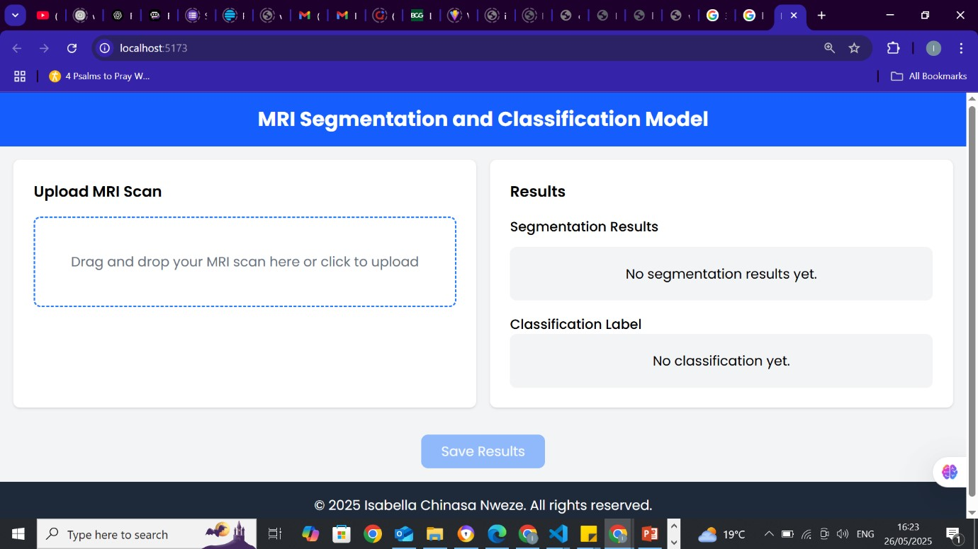
Figure 4.4: Upload Page
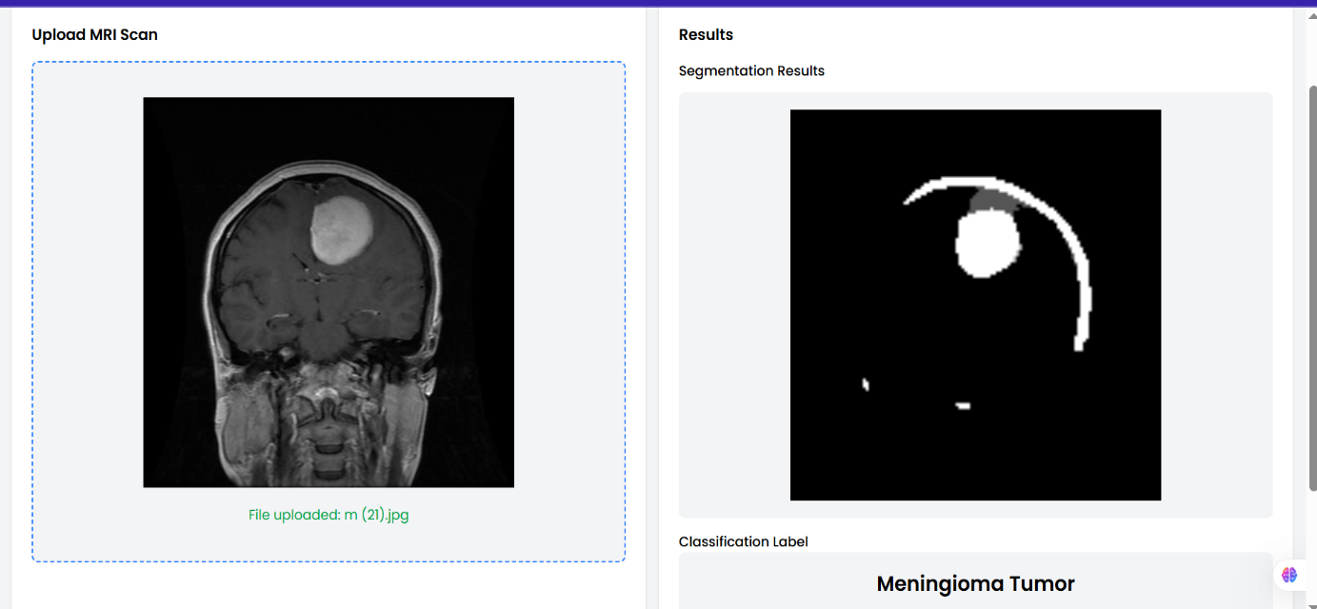
Figure 4.5: Results on Upload Page

CHAPTER FIVE
SUMMARY, RECOMMENDATIONS AND CONCLUSION

5.1 Summary
Multi-task learning is an emerging field in machine learning with many interesting prospects. In this project multi-task learning was used to provide a unified architecture for brain tumour segmentation and classification.
However the problem typically associated with multi-task environments, is loss balancing among the tasks involved, in a way that ensures that no task is dominating the other during training. The adaptive loss balancing algorithm used in this project, presents a dynamic way of balancing task and ensuring optimality.
This project used EfficientNet-B0 for tumour classification and U-Net from the MONAI library for segmentation. The shared input and joint training approach allowed for mutual learning between tasks, while an adaptive loss balancing strategy based on task uncertainty was employed to dynamically assign appropriate loss weights to each task during training. Two publicly available standard datasets were used to support the model: the BraTS 2020 dataset (used for segmentation) and the Figshare brain MRI dataset (used for classification). Both datasets were pre-processed and combined into a unified format to facilitate joint training.
Due to hardware limitations, the model was trained over 70 epochs instead of the intended 100, which constrained its full potential. Nevertheless, the model was successfully trained and evaluated using IoU Score and Accuracy for segmentation and F1 score and accuracy for classification . These metrics showed a strong performance across both tasks indicating that the adaptive loss balancing algorithm was effective in balancing learning and optimization.
The final model was integrated into a real-time web application using Flask and React.js, enabling users to upload MRI scans and receive both classification and segmentation results in real time. This application represents a practical deployment of the system for real-world use, particularly in clinical settings with limited resources.

5.2 Recommendations
The following recommendations are made for future development and research:
- Upgrade of Hardware Resources: During the process of training the model, it was discovered that the computational power required to train the model, in terms of RAM and storage was not available. This limited the number of epochs that was able to train from 100 to 70.
- Expand Diagnostic Scope: The scope of this project is limited to only the segmentation and classification of tumours, future improvements to the project could include other diagnostic tasks such as tumour localization, or progression, thus enhancing the usefulness to low resource clinical settings.
- Accept other Imaging Modalities: Future iterations of the model should be able to support additional brain imaging modalities such as CT scans alongside MRI. This extension would improve the model’s applicability across a broader range of clinical scenarios, especially in settings where MRI may not be readily available. This idea was suggested during the evaluation phase by Dr. Alex, the Director of Covenant University Medical Centre, who emphasized the potential impact of a multi-modal model in improving diagnostic flexibility and accessibility in real-world medical environments.

5.3 Limitations of the Study
The major limitations of this study include:
- Limited computational resources, including slow GPU and small RAM reduced the number of epochs that the model could train leading to a reduced accuracy that affected the segmentation IoU score.
- The multi-task model only accepts one type of scan input which is MRI, it is not multi-modal so it cannot provide diagnosis, for other types of brain scans such as CT scans, which are also commonly used.

5.4 Conclusion
This final year project was able to successfully segment and classify brain tumours in a real time web application environment. A unified MRI architecture was built by leveraging the architectural strengths of EfficientNet and U-Net, and addressing task imbalance through a dynamic adaptive loss balancing algorithm
Despite limitations in computational resources, the system achieved high accuracy and was integrated into a web application for real-time medical inference. The contribution of this work is significant in both academia and practical implications, especially in resource-constrained clinical settings.
With further optimization, enhanced hardware, and multi-modality, this system has the potential to become a critical tool in medical imaging and diagnostics. It also makes a valuable contribution to the field of multi-task learning and intelligent medical systems.

REFERENCES
Alshomrani, F. (2024). A Unified Pipeline for Simultaneous Brain Tumor Classification and Segmentation Using Fine-Tuned CNN and Residual UNet Architecture. Life, 14(9), 1143. https://doi.org/10.3390/life14091143

Cao, H., Wang, Y., Chen, J., Jiang, D., Zhang, X., Tian, Q., & Wang, M. (2021). Swin-Unet: Unet-like Pure Transformer for Medical Image Segmentation (Version 1). arXiv. https://doi.org/10.48550/ARXIV.2105.05537

Chen, Z., Badrinarayanan, V., Lee, C.-Y., & Rabinovich, A. (2017). GradNorm: Gradient Normalization for Adaptive Loss Balancing in Deep Multitask Networks. https://doi.org/10.48550/ARXIV.1711.02257

Cipolla, R., Gal, Y., & Kendall, A. (2018). Multi-task Learning Using Uncertainty to Weigh Losses for Scene Geometry and Semantics. 2018 IEEE/CVF Conference on Computer Vision and Pattern Recognition, 7482–7491. https://doi.org/10.1109/CVPR.2018.00781

Du, G., Lee, J., Li, J., Jiang, R., Guo, Y., Yu, S., Liu, H., Goh, S. K., Tang, H.-K., He, D., & Zhang, M. (2024). Parameter Competition Balancing for Model Merging (No. arXiv:2410.02396). arXiv. https://doi.org/10.48550/arXiv.2410.02396

Gong, T., Lee, T., Stephenson, C., Renduchintala, V., Padhy, S., Ndirango, A., Keskin, G., & Elibol, O. H. (2019). A Comparison of Loss Weighting Strategies for Multi task Learning in Deep Neural Networks. IEEE Access, 7, 141627–141632. https://doi.org/10.1109/ACCESS.2019.2943604

Hervella, Á. S., Rouco, J., Novo, J., & Ortega, M. (2024). Multi-Adaptive Optimization for multi-task learning with deep neural networks. Neural Networks, 170, 254–265. https://doi.org/10.1016/j.neunet.2023.11.038

Hua, H., Li, Y., Wang, T., Dong, N., Li, W., & Cao, J. (2023). Edge Computing with Artificial Intelligence: A Machine Learning Perspective. ACM Computing Surveys, 55(9), 1–35. https://doi.org/10.1145/3555802

Jaradat, S., Nayak, R., Paz, A., Ashqar, H. I., & Elhenawy, M. (2024). Multitask Learning for Crash Analysis: A Fine-Tuned LLM Framework Using Twitter Data. Smart Cities, 7(5), 2422–2465. https://doi.org/10.3390/smartcities7050095

Kaur, S., Singla, J., Nkenyereye, L., Jha, S., Prashar, D., Joshi, G. P., El-Sappagh, S., Islam, Md. S., & Islam, S. M. R. (2020). Medical Diagnostic Systems Using Artificial Intelligence (AI) Algorithms: Principles and Perspectives. IEEE Access, 8, 228049–228069. https://doi.org/10.1109/ACCESS.2020.3042273

Khozeimeh, F., Sharifrazi, D., Izadi, N. H., Joloudari, J. H., Shoeibi, A., Alizadehsani, R., Gorriz, J. M., Hussain, S., Sani, Z. A., Moosaei, H., Khosravi, A., Nahavandi, S., & Islam, S. M. S. (2021). Combining a Convolutional Neural Network with Autoencoders to Predict the Survival Chance of COVID-19 Patients. https://doi.org/10.48550/ARXIV.2104.08954

Lee, S., & Son, Y. (2022). Multitask learning with single gradient step update for task balancing. Neurocomputing, 467, 442–453. https://doi.org/10.1016/j.neucom.2021.10.025

Li, C., Ding, S., Zou, N., Hu, X., Jiang, X., & Zhang, K. (2023). Multi-task learning with dynamic re-weighting to achieve fairness in healthcare predictive modeling. Journal of Biomedical Informatics, 143, 104399. https://doi.org/10.1016/j.jbi.2023.104399

Lin, B., Jiang, W., Ye, F., Zhang, Y., Chen, P., Chen, Y.-C., Liu, S., & Kwok, J. T. (2023). Dual-Balancing for Multi-Task Learning (No. arXiv:2308.12029). arXiv. https://doi.org/10.48550/arXiv.2308.12029

Liu, S., Wang, H., Li, Y., Li, X., Cao, G., & Cao, W. (2022). AHU-MultiNet: Adaptive loss balancing based on homoscedastic uncertainty in multi-task medical image segmentation network. Computers in Biology and Medicine, 150, 106157. https://doi.org/10.1016/j.compbiomed.2022.106157

McCaughan, A. N., Oripov, B. G., Ganesh, N., Nam, S. W., Dienstfrey, A., & Buckley, S. M. (2023). Multiplexed gradient descent: Fast online training of modern datasets on hardware neural networks without backpropagation. APL Machine Learning, 1(2), 026118. https://doi.org/10.1063/5.0157645

Morgan, E., & Nwatuzor, C. (2020). Starting a neurosurgical service in a Southern Nigeria rural community. Prospect, challenges, and future—The Irrua experience. Egyptian Journal of Neurosurgery, 35(1), 6. https://doi.org/10.1186/s41984-020-00081-y

Mutreja, G., & Bittner, K. (2025). Efficient Building Roof Type Classification: A Domain-Specific Self-Supervised Approach (No. arXiv:2503.22251). arXiv. https://doi.org/10.48550/arXiv.2503.22251

Nisar, M. A., Shirahama, K., Irshad, M. T., Huang, X., & Grzegorzek, M. (2023). A Hierarchical Multitask Learning Approach for the Recognition of Activities of Daily Living Using Data from Wearable Sensors. Sensors, 23(19), 8234. https://doi.org/10.3390/s23198234

Obonyo, S., & Ruiru, D. (2019). Multitask Learning or Transfer Learning? Application to Cancer Detection: Proceedings of the 11th International Joint Conference on Computational Intelligence, 548–555. https://doi.org/10.5220/0008495805480555

Rabby, S. F., Arafat, M. A., & Hasan, T. (2024). BT-Net: An end-to-end multi-task architecture for brain tumor classification, segmentation, and localization from MRI images. Array, 22, 100346. https://doi.org/10.1016/j.array.2024.100346

Ryu, C., Lee, C., Choi, H. J., Lee, C.-H., Jeon, B., Chie, E. K., & Kim, Y.-G. (2023). Trainable Weights for Multitask Learning. IEEE Access, 11, 105633–105641. https://doi.org/10.1109/ACCESS.2023.3319072

Shan, T., Guo, R., Li, M., Yang, F., Xu, S., & Liang, L. (2022). Application of Multitask Learning for 2-D Modeling of Magnetotelluric Surveys: TE Case. IEEE Transactions on Geoscience and Remote Sensing, 60, 1–9. https://doi.org/10.1109/TGRS.2021.3101119

Song, M., Yang, Z., Triantafyllopoulos, A., Jing, X., Karas, V., Jiangjian, X., Zhang, Z., Yoshiharu, Y., & Schuller, B. W. (2022). Dynamic Restrained Uncertainty Weighting Loss for Multitask Learning of Vocal Expression (No. arXiv:2206.11049). arXiv. https://doi.org/10.48550/arXiv.2206.11049

Standley, T., Zamir, A. R., Chen, D., Guibas, L., Malik, J., & Savarese, S. (2019). Which Tasks Should Be Learned Together in Multi-task Learning? (Version 4). arXiv. https://doi.org/10.48550/ARXIV.1905.07553

Tan, M., & Le, Q. V. (2019). EfficientNet: Rethinking Model Scaling for Convolutional Neural Networks. https://doi.org/10.48550/ARXIV.1905.11946

Tian, K., Mitchell, E., Yao, H., Manning, C. D., & Finn, C. (2023). Fine-tuning Language Models for Factuality (Version 1). arXiv. https://doi.org/10.48550/ARXIV.2311.08401

Trinh, Q.-H., Mau, T.-H. N., Zosimov, R., & Nguyen, M.-V. (2022). EfficientNet for Brain-Lesion classification (Version 1). arXiv. https://doi.org/10.48550/ARXIV.2208.04616

Yang, Z., Yin, Y., Kong, C., Chi, T., Tao, W., Zhang, Y., & Xu, T. (2024). ShennongAlpha: An AI-driven sharing and collaboration platform for intelligent curation, acquisition, and translation of natural medicinal material knowledge. https://doi.org/10.48550/ARXIV.2401.00020

Yuan, J., & Zhang, R. (2023). Equitable Multi-task Learning (No. arXiv:2306.09373). arXiv. https://doi.org/10.48550/arXiv.2306.09373

Zakaria, R., Abdelmajid, H., & Zitouni, D. (2022). Deep Learning in Medical Imaging: A Review. In J. K. Mandal, Sanjay, J. S. Banerjee, & S. Nayak, Applications of Machine Intelligence in Engineering (1st ed., pp. 131–144). CRC Press. https://doi.org/10.1201/9781003269793-15

Zhai, S., Wang, J., Zhang, T., Huang, F., Zhang, Q., Zhou, M., Hou, J., Qiao, Y., & Liu, Y. (2024). Building Open-Ended Embodied Agent via Language-Policy Bidirectional Adaptation (Version 3). arXiv. https://doi.org/10.48550/ARXIV.2401.00006

Zhai, Z., Chen, F., Yu, H., Hu, J., Zhou, X., & Xu, H. (2024). PS-MTL-LUCAS: A partially shared multi-task learning model for simultaneously predicting multiple soil properties. Ecological Informatics, 82, 102784. https://doi.org/10.1016/j.ecoinf.2024.102784

Zhang, Y., & Yang, Q. (2017). A Survey on Multi-Task Learning (Version 3). arXiv. https://doi.org/10.48550/ARXIV.1707.08114

